Java Keywords
Java keywords are also known as reserved words. Keywords are particular words which acts as a key to a code. These are predefined words by Java so it cannot be used as a variable or object name.

List of Java Keywords
A list of Java keywords or reserved words are given below:
- abstract: Java abstract keyword is used to declare abstract class. Abstract class can provide the implementation of interface. It can have abstract and non-abstract methods.
- boolean: Java boolean keyword is used to declare a variable as a boolean type. It can hold True and False values only.
- break: Java break keyword is used to break loop or switch statement. It breaks the current flow of the program at specified condition.
- byte: Java byte keyword is used to declare a variable that can hold an 8-bit data values.
- case: Java case keyword is used to with the switch statements to mark blocks of text.
- catch: Java catch keyword is used to catch the exceptions generated by try statements. It must be used after the try block only.
- char: Java char keyword is used to declare a variable that can hold unsigned 16-bit Unicode characters
- class: Java class keyword is used to declare a class.
- continue: Java continue keyword is used to continue the loop. It continues the current flow of the program and skips the remaining code at the specified condition.
- default: Java default keyword is used to specify the default block of code in a switch statement.
- do: Java do keyword is used in control statement to declare a loop. It can iterate a part of the program several times.
- double: Java double keyword is used to declare a variable that can hold a 64-bit floating-point numbers.
- else: Java else keyword is used to indicate the alternative branches in an if statement.
- enum: Java enum keyword is used to define a fixed set of constants. Enum constructors are always private or default.
- extends: Java extends keyword is used to indicate that a class is derived from another class or interface.
- final: Java final keyword is used to indicate that a variable holds a constant value. It is applied with a variable. It is used to restrict the user.
- finally: Java finally keyword indicates a block of code in a try-catch structure. This block is always executed whether exception is handled or not.
- float: Java float keyword is used to declare a variable that can hold a 32-bit floating-point number.
- for: Java for keyword is used to start a for loop. It is used to execute a set of instructions/functions repeatedly when some conditions become true. If the number of iteration is fixed, it is recommended to use for loop.
- if: Java if keyword tests the condition. It executes the if block if condition is true.
- implements: Java implements keyword is used to implement an interface.
- import: Java import keyword makes classes and interfaces available and accessible to the current source code.
- instanceof: Java instanceof keyword is used to test whether the object is an instance of the specified class or implements an interface.
- int: Java int keyword is used to declare a variable that can hold a 32-bit signed integer.
- interface: Java interface keyword is used to declare an interface. It can have only abstract methods.
- long: Java long keyword is used to declare a variable that can hold a 64-bit integer.
- native: Java native keyword is used to specify that a method is implemented in native code using JNI (Java Native Interface).
- new: Java new keyword is used to create new objects.
- null: Java null keyword is used to indicate that a reference does not refer to anything. It removes the garbage value.
- package: Java package keyword is used to declare a Java package that includes the classes.
- private: Java private keyword is an access modifier. It is used to indicate that a method or variable may be accessed only in the class in which it is declared.
- protected: Java protected keyword is an access modifier. It can be accessible within package and outside the package but through inheritance only. It can't be applied on the class.
- public: Java public keyword is an access modifier. It is used to indicate that an item is accessible anywhere. It has the widest scope among all other modifiers.
- return: Java return keyword is used to return from a method when its execution is complete.
- short: Java short keyword is used to declare a variable that can hold a 16-bit integer.
- static: Java static keyword is used to indicate that a variable or method is a class method. The static keyword in Java is used for memory management mainly.
- strictfp: Java strictfp is used to restrict the floating-point calculations to ensure portability.
- super: Java super keyword is a reference variable that is used to refer parent class object. It can be used to invoke immediate parent class method.
- switch: The Java switch keyword contains a switch statement that executes code based on test value. The switch statement tests the equality of a variable against multiple values.
- synchronized: Java synchronized keyword is used to specify the critical sections or methods in multithreaded code.
- this: Java this keyword can be used to refer the current object in a method or constructor.
- throw: The Java throw keyword is used to explicitly throw an exception. The throw keyword is mainly used to throw custom exception. It is followed by an instance.
- throws: The Java throws keyword is used to declare an exception. Checked exception can be propagated with throws.
- transient: Java transient keyword is used in serialization. If you define any data member as transient, it will not be serialized.
- try: Java try keyword is used to start a block of code that will be tested for exceptions. The try block must be followed by either catch or finally block.
- void: Java void keyword is used to specify that a method does not have a return value.
- volatile: Java volatile keyword is used to indicate that a variable may change asynchronously.
- while: Java while keyword is used to start a while loop. This loop iterates a part of the program several times. If the number of iteration is not fixed, it is recommended to use while loop.

Data Types in Java
Data types specify the different sizes and values that can be stored in the variable. There are two types of data types in Java:
- Primitive data types: The primitive data types include boolean, char, byte, short, int, long, float and double.
- Non-primitive data types: The non-primitive data types include Classes, Interfaces, and Arrays.

Java Primitive Data Types
In Java language, primitive data types are the building blocks of data manipulation. These are the most basic data types available in Java language.
There are 8 types of primitive data types:
- boolean data type
- byte data type
- char data type
- short data type
- int data type
- long data type
- float data type
- double data type
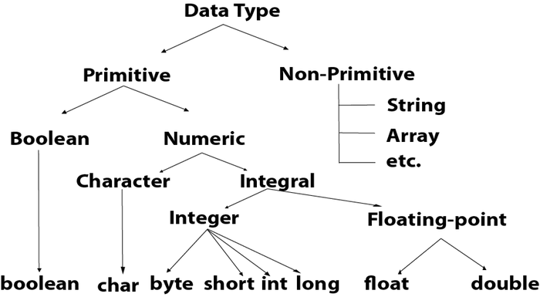
Data Type | Default Value | Default size
boolean | false | 1 bit
char | '\u0000' | 2 byte
byte | 0 | 1 byte
short | 0 | 2 byte
int | 0 | 4 byte
long | 0L | 8 byte
float | 0.0f | 4 byte
double | 0.0d | 8 byte

Boolean Data Type
The Boolean data type is used to store only two possible values: true and false. This data type is used for simple flags that track true/false conditions.
The Boolean data type specifies one bit of information, but its "size" can't be defined precisely.
Example: Boolean one = false

Byte Data Type
The byte data type is an example of primitive data type. It isan 8-bit signed two's complement integer. Its value-range lies between -128 to 127 (inclusive). Its minimum value is -128 and maximum value is 127. Its default value is 0.
The byte data type is used to save memory in large arrays where the memory savings is most required. It saves space because a byte is 4 times smaller than an integer. It can also be used in place of "int" data type.
Example: byte a = 10, byte b = -20

Short Data Type
The short data type is a 16-bit signed two's complement integer. Its value-range lies between -32,768 to 32,767 (inclusive). Its minimum value is -32,768 and maximum value is 32,767. Its default value is 0.
The short data type can also be used to save memory just like byte data type. A short data type is 2 times smaller than an integer.
Example: short s = 10000, short r = -5000

Int Data Type
The int data type is a 32-bit signed two's complement integer. Its value-range lies between - 2,147,483,648 (-2^31) to 2,147,483,647 (2^31 -1) (inclusive). Its minimum value is - 2,147,483,648and maximum value is 2,147,483,647. Its default value is 0.
The int data type is generally used as a default data type for integral values unless if there is no problem about memory.
Example: int a = 100000, int b = -200000

Long Data Type
The long data type is a 64-bit two's complement integer. Its value-range lies between -9,223,372,036,854,775,808(-2^63) to 9,223,372,036,854,775,807(2^63 -1)(inclusive). Its minimum value is - 9,223,372,036,854,775,808and maximum value is 9,223,372,036,854,775,807. Its default value is 0. The long data type is used when you need a range of values more than those provided by int.
Example: long a = 100000L, long b = -200000L

Float Data Type
The float data type is a single-precision 32-bit IEEE 754 floating point.Its value range is unlimited. It is recommended to use a float (instead of double) if you need to save memory in large arrays of floating point numbers. The float data type should never be used for precise values, such as currency. Its default value is 0.0F.
Example: float f1 = 234.5f

Double Data Type
The double data type is a double-precision 64-bit IEEE 754 floating point. Its value range is unlimited. The double data type is generally used for decimal values just like float. The double data type also should never be used for precise values, such as currency. Its default value is 0.0d.
Example: double d1 = 12.3

Char Data Type
The char data type is a single 16-bit Unicode character. Its value-range lies between '\u0000' (or 0) to '\uffff' (or 65,535 inclusive).The char data type is used to store characters.
Example: char letterA = 'A'

Why char uses 2 byte in java and what is \u0000 ?
It is because java uses Unicode system not ASCII code system. The \u0000 is the lowest range of Unicode system. To get detail explanation about Unicode visit next page.

Java Variables
A variable is a container which holds the value while the Java program is executed. A variable is assigned with a data type.
Variable is a name of memory location. There are three types of variables in java: local, instance and static.
There are two types of data types in Java: primitive and non-primitive.

Variable
Variable is name of reserved area allocated in memory. In other words, it is a name of memory location. It is a combination of "vary + able" that means its value can be changed.
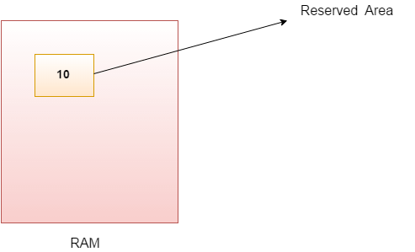
- int data=50;//Here data is variable

Types of Variables
There are three types of variables in Java:
- local variable
- instance variable
- static variable
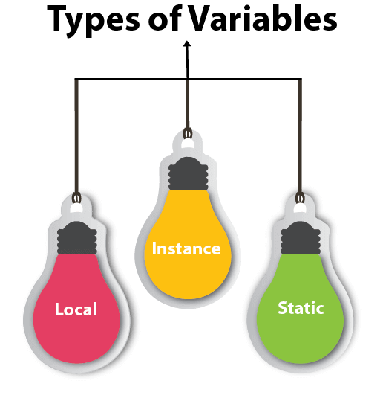

1) Local Variable
A variable declared inside the body of the method is called local variable. You can use this variable only within that method and the other methods in the class aren't even aware that the variable exists.
A local variable cannot be defined with "static" keyword.

2) Instance Variable
A variable declared inside the class but outside the body of the method, is called instance variable. It is not declared as static.
It is called instance variable because its value is instance specific and is not shared among instances.

3) Static variable
A variable which is declared as static is called static variable. It cannot be local. You can create a single copy of static variable and share among all the instances of the class. Memory allocation for static variable happens only once when the class is loaded in the memory.

Example to understand the types of variables in java
class A{
int data=50;//instance variable
static int m=100;//static variable
void method(){
int n=90;//local variable
}
}//end of class

Java Variable Example: Add Two Numbers
class Simple{
public static void main(String[] args){
int a=10;
int b=10;
int c=a+b;
System.out.println(c);
}}
Output:
20

Java Variable Example: Widening
class Simple{
public static void main(String[] args){
int a=10;
float f=a;
System.out.println(a);
System.out.println(f);
}}
Output:
10
10.0

Java Variable Example: Narrowing (Typecasting)
class Simple{
public static void main(String[] args){
float f=10.5f;
//int a=f;//Compile time error
int a=(int)f;
System.out.println(f);
System.out.println(a);
}}
Output:
10.5
10

Java Variable Example: Overflow
class Simple{
public static void main(String[] args){
//Overflow
int a=130;
byte b=(byte)a;
System.out.println(a);
System.out.println(b);
}}
Output:
130
-126

Java Variable Example: Adding Lower Type
class Simple{
public static void main(String[] args){
byte a=10;
byte b=10;
//byte c=a+b;//Compile Time Error: because a+b=20 will be int
byte c=(byte)(a+b);
System.out.println(c);
}}
Output:
20

Unicode System
Unicode is a universal international standard character encoding that is capable of representing most of the world's written languages.

Why java uses Unicode System?
Before Unicode, there were many language standards:
- ASCII (American Standard Code for Information Interchange) for the United States.
- ISO 8859-1 for Western European Language.
- KOI-8 for Russian.
- GB18030 and BIG-5 for chinese, and so on.

