Enzymes
Enzymes are highly specialized molecules which act as biocatalyst. The reacting molecules are called substrate and substances formed are the products. In 1897 Eduard Buchner discovered that yeast extracts could ferment sugar to alcohol, proving that fermentation was promoted by molecules that continued to function when removed from cells. Frederick W. Kühne called these molecules enzymes.

Nature of enzymes
- Enzymes have extraordinary catalytic power, often far greater than that of synthetic or inorganic catalysts.
- They have a high degree of specificity for their substrates, they accelerate chemical reactions tremendously.
- They function in aqueous solutions under very mild conditions of temperature and pH.
- Enzymes are central to all biochemical process. Acting in organised sequences, they catalyze the hundreds of stepwise reactions.

Structural properties of enzymes

- Apart from some exception of a small group of catalytic RNA, all enzymes are proteins.
- Their catalytic activity depends on the integrity of their native protein conformation. If an enzyme is denatured or dissociated into its subunits, catalytic activity is usually lost.
- Enzymes, like other proteins, have molecular weights ranging from about 12,000 to more than 1 million.
- Some enzyme proteins are modified covalently by phosphorylation, glycosylation and other processes. Many of these alterations are involved in the regulation of enzyme activity.
- Some enzymes require no chemical groups for activity other than their amino acid residues. Others require an additional non protein chemical component called a cofactor.
- A complete, catalytically active enzyme together with its bound coenzyme and/or metal ions is called a holoenzyme. The protein part of such an enzyme is called the apoenzyme or apoprotein.
Cofactors are of two types:
- A coenzyme or metal ion that is very tightly or even covalently bound to the enzyme protein is called a prosthetic group. Example: inorganic ions, such as Fe²⁺, Mg²⁺, Mn²⁺, or Zn²⁺
- Often the cofactor is loosely attached to the apoenzyme. It can even dissociate from the enzyme protein after products have been formed, such a loosely bound cofactor is called a coenzyme. Coenzymes act as transient carriers of specific functional groups. Most are derived from vitamins.
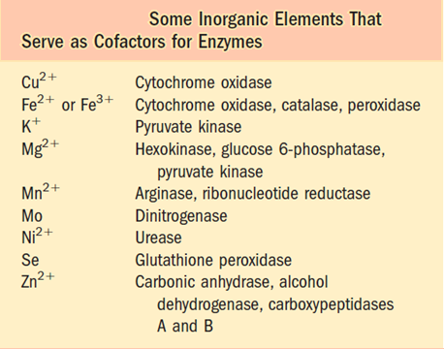

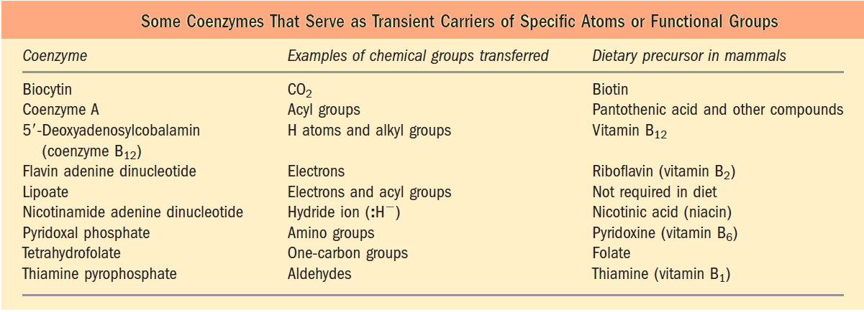

Classification of enzymes

Enzymes are classified by the reactions they catalyze.

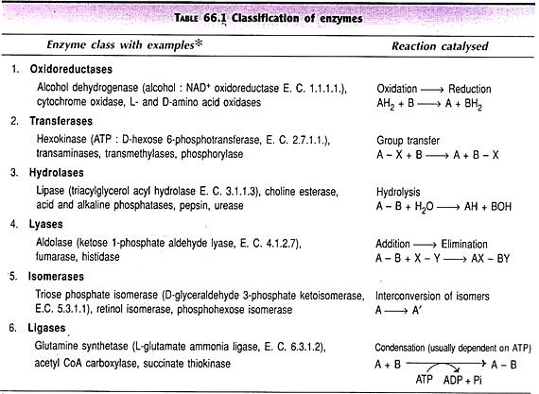

Nomenclature of enzymes

Each enzyme is assigned a four-part classification number and a systematic name, which identifies the reaction it catalyses. As an example, the formal systematic name of the enzyme catalysing the reaction:
ATP + D-glucose ADP + D-glucose 6-phosphate
is ATP: glucose phosphotransferase, which indicates that it catalyses the transfer of a phosphoryl group from ATP to glucose. Its Enzyme Commission number (E.C. number) is 2.7.1.1. The first number (2) denotes the class name (transferase); the second number (7), the subclass (phosphotransferase); the third number (1), a phosphotransferase with a hydroxyl group as acceptor; and the fourth number (1), D-glucose as the phosphoryl group acceptor. For many enzymes, a trivial name is more commonly used—in this case hexokinase.

