Mycobacterium tuberculosis
The famous pioneering microbiologist Robert Koch, the founder of the field of medical microbiology, isolated and described the causative agent of tuberculosis, Mycobacterium tuberculosis, in 1882.
The Mycobacteria are rod shaped, aerobic bacteria that do not form spores. Although they do not readily, once stained they resist decolorization by acid or alcohol and therefore called “acid-fast” bacilli and also share the property of being acid-fast due to the waxy mycolic acid constituent of their cell walls. Mycolic acid allows these organisms to retain the red dye carbol-fuchsin after washing a mycobacterial smear on a slide in 3% hydrochloric acid in alcohol. Colonies of M. tuberculosis grow slowly on plates and have a characteristically wrinkled morphology (fig 29.15). Mycobacteria tuberculosis causes tuberculosis and is very important pathogen of humans.
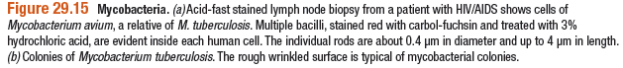
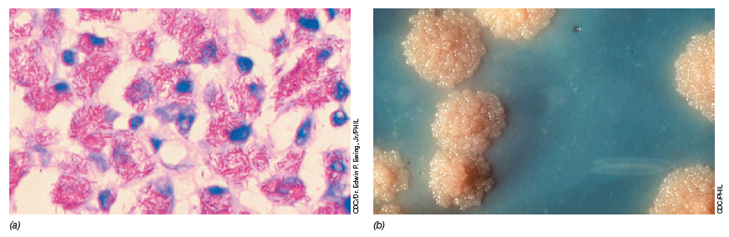
- Pathogenesis
Mycobacteria are emitted in droplets smaller than 25 μm in diameter when infected persons cough, sneeze, or speak.
The droplets evaporate, leaving organisms that are small enough, when inhaled, to be deposited in alveoli.
Inside the alveoli, the host’s immune system responds by release of cytokines and lymphokines that stimulate monocytes and macrophages.
Mycobacteria begin to multiply within macrophages. Some of the macrophages develop an enhanced ability to kill the organism, but others may be killed by the bacilli. One to 2 months after exposure, pathogenic lesions associated with infection appear in the lung. Two types of lesions as described later under Pathology may develop. Resistance and hypersensitivity of the host greatly influence development of disease and the type of lesions that are seen.
Two principle lesions

- Exudative type - This consist of an acute inflammatory reaction, with edema fluid, polymorphonuclear leukocyctes, and later, monocytes around the tubercle bacilli. This type seen particularly in lung tissue, where it resembles bacterial pneumonia.
- Productive type- when fully developed, this lesion, a chronic granuloma, consist of three zone:
i). a central area of large, multinucleated giant cells containing tubercle bacilli
ii). A mid zone of pale epithelioid cells, often arranged radially and
iii). A peripheral zone of fibroblasts, lymphocytes and monocytes.
Later, peripheral fibrous tissue develops, and the central area under goes caseation necrosis. Such lesion is called a tubercle. A caseous tubercle may break into a bronchous, empty its contents there, and form a cavity. It may subsequently heal by fibrosis or calcification.

- Transmission
Tubercle bacilli spread in the host by direct extension, through the lymphatic channels and bloodstream, and via the bronchi and gastrointestinal tract.

In the first infection, tubercle bacilli always spread from the initial site via lymphatics to the regional lymph nodes. The bacilli may spread farther and reach the bloodstream, which in turn distributes bacilli to all organs. The bloodstream can be invaded also by erosion of a vein by a caseating tubercle or lymph node. If a caseating lesion discharges its contents into a bronchusm they are aspirated and distributed to other parts of the lungs or are swallowed and passed into the stomach and intestines.

- Symptoms
Since the tubercle bacillus can involve every organ system, its clinical manisfestations are protean.

Fatigue, weakness, weight loss and fever may be signs of tuberculous disease.
Pulmonary involvement giving rise to chronic cough and spitting of blood usually is associated with far-advanced lesions.

- Prophaylaxis -Two major drugs used to treat tuberculosis are isoniazid (INH) and rifampin (RMP).
The other first-line drugs are pyrazinamide (PZA), ethambutol (EMB), and streptomycin. Second-line drugs are more toxic or less effective (or both), and they should be used in therapy only under extenuating circumstances (eg, treatment failure, multiple drug resistance). Second-line drugs include kanamycin, capreomycin, ethionamide, cycloserine, ofloxacin, and ciprofloxacin.

Multidrug-resistant M tuberculosis (resistant to both INH and RMP) is a major problem in tuberculosis treatment and control. Such strains are prevalent in certain geographic areas and certain populations (eg, hospitals, prisons). There have been many outbreaks of tuberculosis with multi drug resistant strains. They are particularly important in persons with HIV infections in resource-poor countries. Persons infected with multidrug-resistant organisms or who are at high risk for such infections, including exposure to another person with such an infection, should be treated according to susceptibility test results for the infecting strain. If susceptibility results are not available, the drugs should be selected according to the known pattern of susceptibility in the community and modified when the susceptibility test results are available. Therapy should include a minimum of three and preferably more than three drugs to which the organisms have demonstrated susceptibility.

- Control
- Prompt and effective treatment of patients with active tuberculosis and careful follow-up of their contacts with tuberculin tests, radiographs, and appropriate treatment are the mainstays of public health tuberculosis control.

- Drug treatment of asymptomatic tuberculin-positive persons in the age groups most prone to develop complications (eg, children) and in tuberculin-positive persons who must receive immunosuppressive drugs greatly reduces reactivation of infection.

- Nonspecific factors may reduce host resistance, thus favoring the conversion of asymptomatic infection into disease. Such factors include starvation, gastrectomy, and suppression of cellular immunity by drugs (eg, corticosteroids) or infection. HIV infection is a major risk factor for tuberculosis.
4. Various living avirulent tubercle bacilli, particularly BCG (an attenuated bovine organism), have been used to induce a certain amount of resistance in those heavily exposed to infection. Vaccination with these organisms is a substitute for primary infection with virulent tubercle bacilli without the danger inherent in the latter. The available vaccines are inadequate from many technical and biologic standpoints. Nevertheless, BCG is given tochildren in many countries. Statistical evidence indicates that an increased resistance for a limited period follows BCG vaccination.

- Eradication of tuberculosis in cattle and pasteurization of milk have greatly reduced M bovis infections.

Abbreviation
BCB Bacillus Calmette-Guerin, an attenuated bovine organisms

Reference
- Jawetz, Medical Microbiology, twenty-third edition, International edition

