Electron microscopy is a valuable tool used to obtain high-resolution images in a variety of applications, including biomedical research, forensics, and technology. Electron microscopes can capture much higher resolution images than light microscopes, contributing information that is otherwise unattainable.
Every electron microscope works by accelerating a focused stream of electrons in a vacuum towards a sample. Interactions between the electron beam and the sample create an image, similar to how optical microscopes use light to capture images. The image created reveals details of a sample’s surface or internal composition, depending on the type of electron microscope that is used.
Scanning Electron Microscopy (SEM) and Transmission Electron Microscopy (TEM) are the two most common types of electron microscopy. TEM and SEM differ in how they work and what types of images they are able to capture. This article will overview SEM and TEM, including what they are, how they work, and how they compare to one another.

What is SEM?
SEM can stand for either Scanning Electron Microscopy or Scanning Electron Microscope. An SEM is a kind of electron microscope that uses a fine beam of focused electrons to scan a sample’s surface. The microscope records information about the interaction between the electrons and the sample, creating a magnified image. SEM has the potential to magnify an image up to 2 million times.

A closer look at an SEM microscope.
SEM images give insight into a sample’s topography and elemental composition. SEM is able to capture 3-D black-and-white images of thin or thick samples. The sample’s size is limited only by the size of the electron microscope chamber.

How does SEM work?
To obtain a high-resolution image, an electron source (also known as an electron gun) emits a stream of high-energy electrons towards a sample. The electron beam is focused using electromagnetic lenses. Once the focused stream reaches the sample, it scans its surface in a rectangular raster.
The interaction between the electron beam and the sample creates secondary electrons, backscattered electrons, and X-rays. These interactions are captured to create a magnified image.

What is TEM?
TEM can stand for Transmission Electron Microscopy or Transmission Electron Microscope (TEM). A TEM is a type of electron microscope that uses a broad beam of electrons to create an image of a sample’s internal structure. A beam of electrons is transmitted through a sample, creating an image that details a sample’s morphology, composition, and crystal structure.

A closer look at a TEM microscope.

Samples must be incredibly thin, often less than 150 nm thick, to allow electrons to pass through them. After the transmission of the electrons through the sample, they arrive at a detector below and a 2-D image is created.

TEMs have an incredible magnification potential of 10-50 million times. The details provided are at the atomic level, the highest resolution of any electron microscope. TEMs are often used to examine molecular and cellular structures.

How does a TEM work?
An electron source sends a beam of electrons through an ultrathin sample. When the electrons penetrate the sample, they pass through lenses below. This data is used to create images directly on a fluorescent screen or onto a computer screen using a charge-coupled device (CCD) camera.

SEM vs TEM
SEM and TEM are both valuable tools in the biological, physical, and chemical sciences. By understanding the differences between these two electron microscopes, scientists can choose the correct type of microscope for their needs.

SEM vs TEM advantages
Scanning Electron Microscopes and Transmission Electron Microscopes each contain unique advantages when compared to the other.
In comparison to TEMs, SEMs:
- Cost less
- Take less time to create an image
- Require less sample preparation
- Accept thicker samples
- Can examine larger samples
In comparison to SEMs, TEMs:
- Create higher resolution images
- Provide crystallographic and atomic data
- Create 2-D images that are often easier to interpret than SEM 3-D images
- Allow users to examine more characteristics of a sample

SEM vs TEM similarities and differences
There are many similarities between SEMs and TEMs. The components of these two high-resolution microscopes are very similar. Each has an electron source/gun that emits an electron stream towards a sample in a vacuum, and each contains lenses and electron apertures to control the electron beam and capture images.

But the differences in function between the two are vast. They differ in how they work, the types of samples that they require, the resolution of images that they create, and more.

The below table summarizes the differences between Scanning Electron Microscopes and Transmission Electron Microscopes.

 | Scanning Electron Microscopes (SEM) | Transmission Electron Microscopes (TEM)
Electron stream | Fine, focused beam | Broad beam
Image taken | Topographical/surface | Internal structure
Resolution | Lower resolution | Higher resolution
Magnification | Up to 2,000,000 times | Up to 50,000,000 times
Image dimension | 3-D | 2-D
Sample thickness | Thin and thick samples okay | Ultrathin samples only
Penetrates sample | No | Yes
Sample restriction | Less restrictive | More restrictive
Sample preparation | Less preparation required | More preparation required
Cost | Less expensive | More expensive
Speed | Faster | Slower
Operation | Easy to use | More complicated; requires training
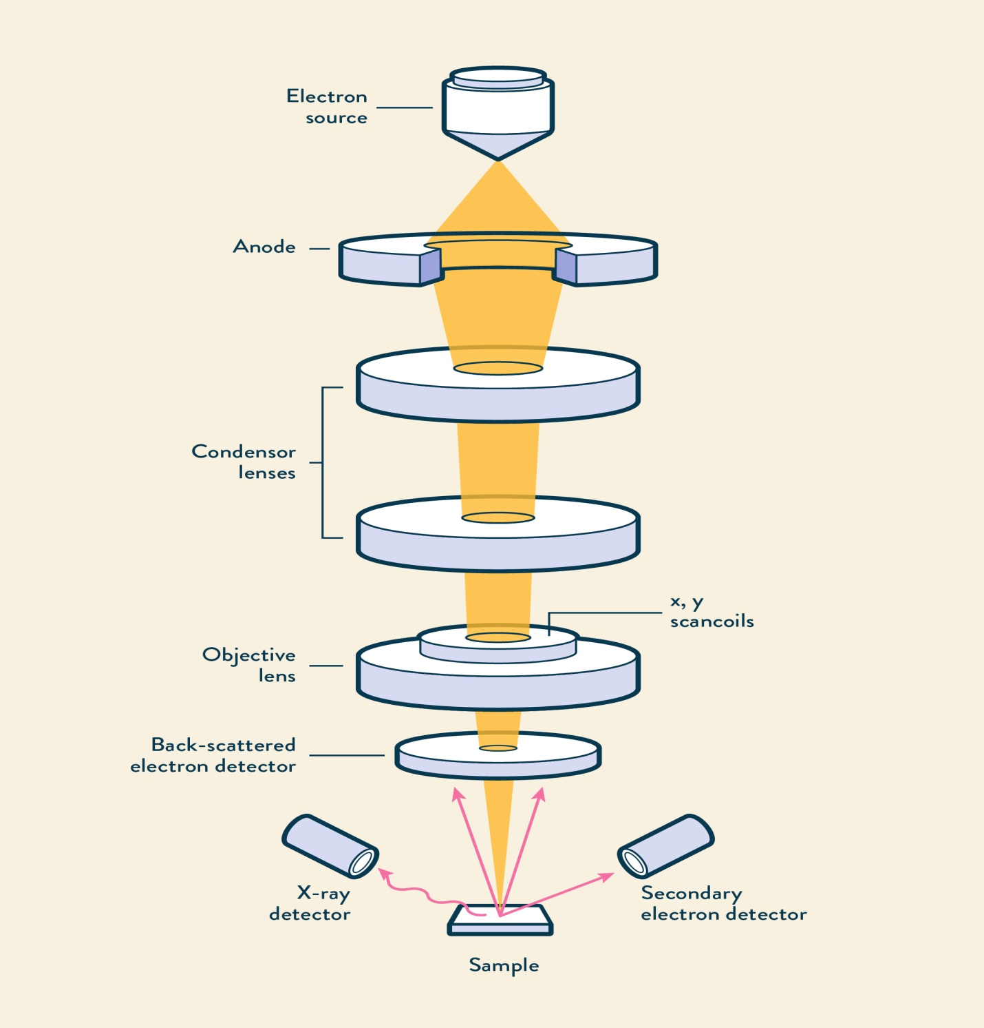
Confocal Scanning Laser Microscopy

A confocal scanning laser microscope (CSLM) is a computercontrolled microscope that couples a laser to a fluorescent microscope. The laser generates a bright three-dimensional image and allows the viewer to access several planes of focus in the specimen (Figure 2.8). To do this, the laser beam is precisely adjusted such that only a particular layer within a specimen is in perfect focus at one time. By precisely illuminating only this
single plane, the CSLM eliminates stray light from other focal planes. Thus, when observing a relatively thick specimen such as a bacterial biofilm (Figure 2.8a), not only can cells on the surface of the biofilm be observed, as would be the case with conventional light microscopy, but cells in the various layers can also be observed by adjusting the plane of focus of the laser beam. Using CSLM it has been possible to improve on the 0.2-mm
resolution of the compound light microscope to a limit of about 0.1 mm.
Cells in CSLM preparations can be stained with fluorescent dyes to make them more distinct (Figure 2.8a). Alternatively, false color can be added to unstained preparations such that different layers in the specimen have different colors (Figure 2.8b). A CLSM employs a computer to assemble digital images for subsequent image processing. Images obtained from the different layers can then be digitally reconstructed to yield a three-dimensional image of the entire specimen. CSLM is widely used in microbial ecology, especially for
identifying specific populations of cells in a microbial habitat or for resolving the different components of a structured microbial community, such as a biofilm (Figure 2.8a) or a microbial mat. In general, CSLM is particularly useful anywhere thick specimens need to be examined for their microbial content with depth.

Fluorescence Microscopy
Many chemical substances absorbs light. After absorbing light of a particular wavelength and energy some substances will then emit light of a longer wavelength and a lesser energy content. Such substances are called fluorescent and the phenomenon is termed fluorescence.

The special features of fluorescence microscopy. A high-intensity mercury lamp is used as the light source and emits white light. The exciter filter transmits only blue light to the specimen and blocks out all other colors. The blue light is reflected downward to the specimen by a dichroic mirror (which reflects light of certain colors but transmits light of other colors). The specimens is stained with a fluorescent dye. Certain portions of the specimen retain the dye others do not. The stained portions absorbs blue light and emit green light, which passes upward, penetrates the dichroic mirror and reaches the barrier filter. This filter allows the green light to pass to the eye; however, it blocks out any residual blue light from the specimen which may not have been completely deflected by the dichroic mirror. Thus the eye perceives the stained portions of the specimen as glowing green against a jet black background, whereas the unstained portions of the specimen are invisible.
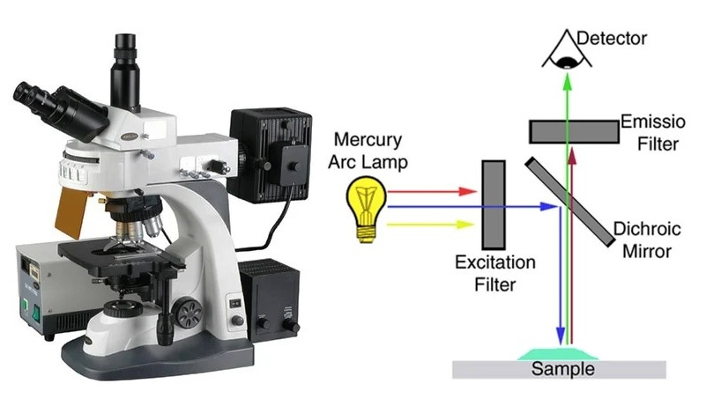

Application of this phenomenon is the basis of fluorescence microscopy. In practice, microorganisms are stained with a fluorescent dye and then illuminated with blue light, the blue light is absorbed and green light emitted by the dye. The function of the exciter filter is to remove all but the blue light, the barrier filter blocks out blue light and allows green light to pass through and reach the eye. Barrier filter are selected on the basis of the dye.

Electron microscopy
Electron microscopy differs from the optical microscopy. The electron microscopy provides tremendous useful magnification, because of the much higher resolution obtainable with the extremely short wavelength of the electron beam used to magnify the specimen.

Electron microscope uses electron beam and magnetic field to produce the image, whereas the light microscope uses the light waves and glass lenses.

When electron microscope employing 60 to 80 kV electrons the wavelength is only 0.005 Å. Å is the abbreviations for angstrom, 1Å equals 1/100,000,000 (10⁻⁸) cm or 1/10,000 (10⁻⁴) µm. it is possible to resolve objects as small as 10 Å. The resolving power of the electron microscope is more than 100 times that of the light microscope, and it produces useful magnification upto X400,000.
For electron microscope, the specimen to be examined is prepared as an extremely thin dry film on small screens and is introduced into the instrument at a point between the magnetic condenser and the magnetic objective. The magnified image may be viewed on a fluorescent screen through an airtight “window” or recorded on a photographic plate by a camera built into the instrument.

