Cost breakdown for well established fermentation processes
The fermenter yield represents the most critical parameter concerning the manufacturing cost of a fermentation product. With increasing yield, the manufacturing cost decreases following an exponential curve (Fig. 1).
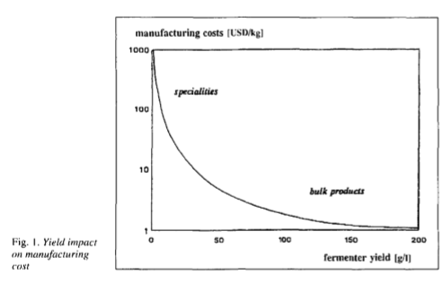
In chemical engineering terms the fermenter yield reflects the productivity of the process, i.e., product quantity per reactor unit volume. Fermented yield, batch cycle and capacity utilization determine the annual plant output and control fixed costs, including processing cost (labour, maintenance, depreciation).
The product yield from the fermentation substrate determines variable or raw material cost. In high-yield fermentation processes, the yield on substrate is a critical parameter for the manufacturing cost. In low-yield processes, the yield on substrate is of less relevance. The variable costs and particularly the influence of the fermentation substrate on the manufacturing cost is often negligible for low-yield processes (Fig. 2). As a result the cost of fermentation substrate as a proportion of the total manufacturing cost is virtually constant over a wide range of fermented yields. Any yield improvement in the low yield range reduces both the absolute variable and fixed cost per kg of product, but does not change their ratios to each other. In high-yield processes, the fermentation substrate must be increased in parallel with increasing volume productivity. With increasing fermenter yields, the substrate cost as a proportion of the total manufacturing cost increases steadily, whilst the relative impact of the fixed cost decreases. This is illustrated in Fig. 2 for bulk product, where the carbohydrate substrate at 70% of total manufacturing cost highlights the difference between specialty and bulk products. The recovery yield influences both variable and fixed costs, determining the amount of finished product harvested from a specific yield for given variable and fixed costs.
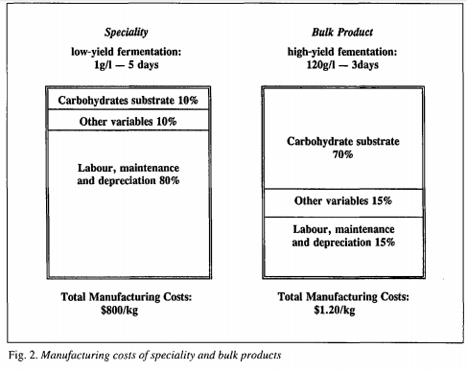
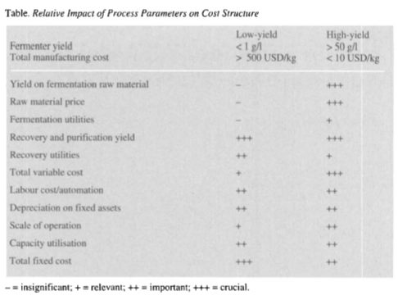
The Table compares the influence of the various factors on the manufacturing cost for low- and high-yield processes: - the raw-material and variable cost are insignificant in low-yield fermentations, but crucial in high-yield processes fixed cost parameters exert significant influence in the total cost of low-yield processes. Due to the competitive market for bulk products, they are also of relevance in high-yield processes.
Low-Yield Fermentation Processes
In these processes, fixed costs, which depend on the installed capacity and variable cost, including fermentation substrate, are constant. The yield depends predominantly on the genetic characteristics of the production strain. Modifications resulting in overproduction of the desired product improves the fermenter yield based on virtually the same variable and fixed cost elements in the fermentation and recovery operations.
As a consequence, the total manufacturing cost per kg of product decreases linearly with any fermented yield improvement. Although the ratio of variable to fixed cost under those circumstances stays constant.
Fixed cost - labour, maintenance and depreciation - dominates the cost structure. The recovery yield influences the total manufacturing cost in a linear manner. If the recovery yield can be increased, the total manufacturing cost decreases proportionately. In low-yield fermentations, the recovery yield is often in the range of 50-70% since the product must be separated and purified from the aqueous phase and from undesired by-products. The annual contribution of maintenance and depreciation is assumed at 15% on fixed assets, equipment and buildings, battery limit. Two other parameters, batch cycle and capacity utilisation, also determine the volume productivity. These parameters only influence the fixed cost allocation of the product volume. Any reduction in batch cycle or increase of capacity utilization decreases the absolute fixed cost per kg of product and its relative impact on the cost structure.
High Yield Fermentation Process
High-yield fermentations apply to primary metabolites, i.e., citric acid, lysine. Product formation depends on a weight by-weight conversion of substrate into product. Any further yield improvement requires a parallel increase of substrate concentration. In consequence, the raw material input per product quantity remains constant, but the allocated fixed cost per product quantity as well as the share of the fixed cost of the total manufacturing cost both decrease.
Any increase in yield increases the cost of the fermentation substrate. In high yield fermentations, the total manufacturing cost no longer decreases linearly with yield improvements, but asymptotically approaches the feedstock cost. In view of the predominance of substrate cost in high yield fermentations, any improvements in recovery yields influence the cost of the feedstock as a proportion of the total manufacturing cost.
The carbohydrate yield or conversion factor for various fermentation products is 50% for ethanol, 78% for citric acid and 95% for lactic acid. The lower the conversion of substrate into product, the higher the relative proportion of feedstock and variable cost of the total manufacturing cost. Similarly, carbohydrate price increases affect both the manufacturing cost as well as the relative share of the variable cost and this leads to cost breakdown in well established fermentation processes.
Labour costs contribute less than 10% of total cost. Any reduction in labour cost due to automation or the choice of a lowwage country is of immediate significance for a commodity product under highly competitive conditions. The overall ratio of variable to fixed cost is only marginally influenced by a reduction in labour cost. The same is true for maintenance and depreciation which in absolute terms, however, contribute a larger proportion of the total fixed and total manufacturing cost than labour costs.
Reference
https://www.ingentaconnect.com/content/scs/chimia/1996/00000050/00000009/art00024?crawler=true

