CONJUGATION.

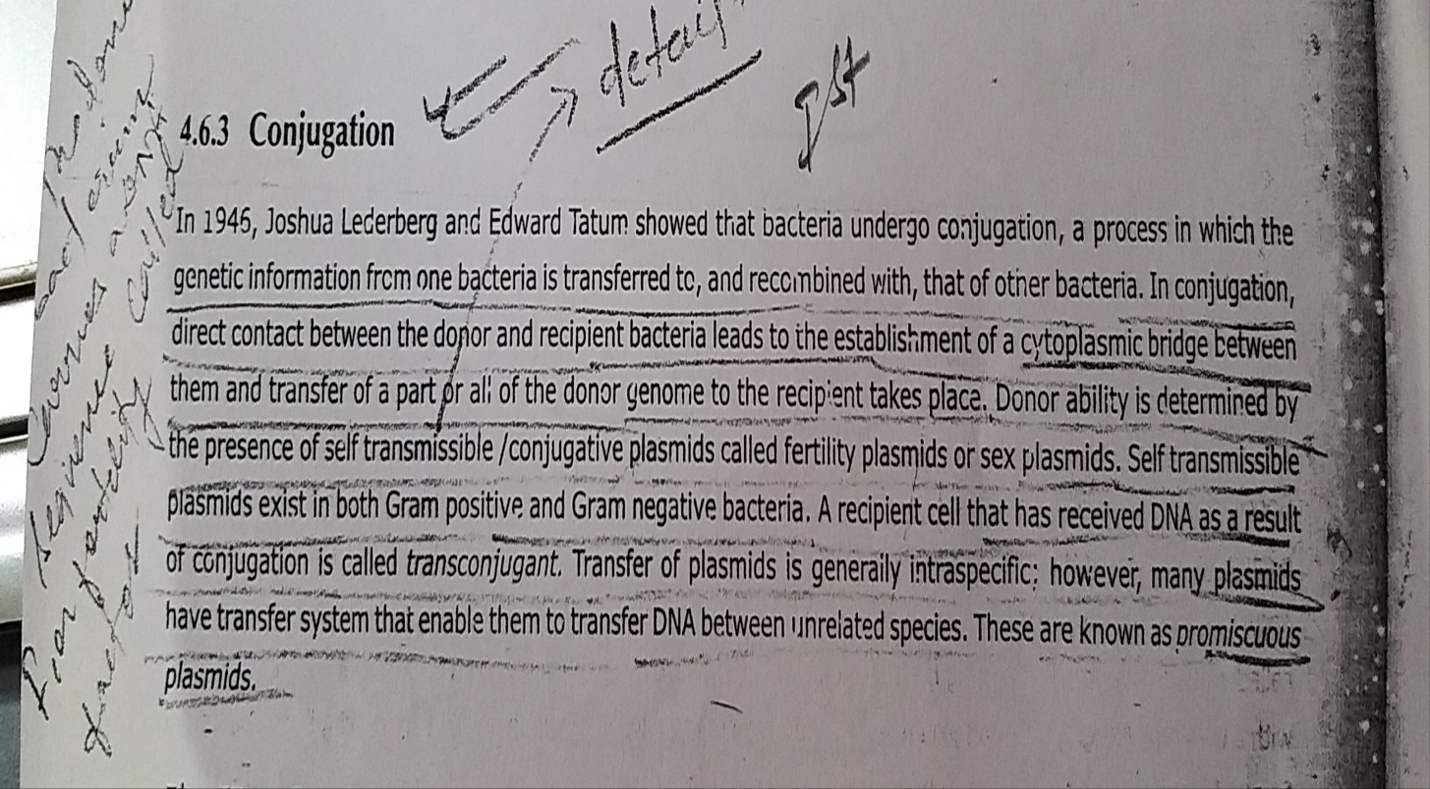

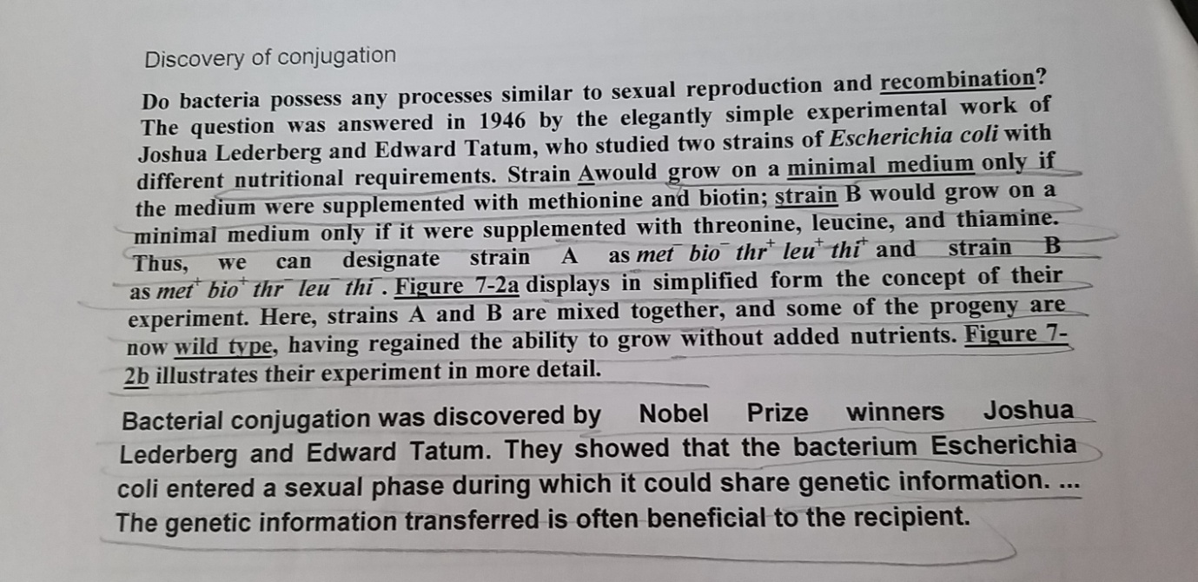
References :
Life Sciences- Fundamental and Practices Part -1
By Pranav Kumar and Usha Mina

