Sauerkraut
The term sauerkraut literally means sour (sauer) cabbage (kraut). It is a traditional German fermented vegetable product that has spread to other cultures and is used in food preparations.
The sequential growth of lactic acid bacteria in sauerkraut has long been recognized. Each lactic acid bacterium dominates the fermentation until its end product becomes inhibitory for its own development and creates another environment suitable for another lactic acid bacterium to take over. The fermentation continues until most of the available fermentable sugars are exhausted. The production of sauerkraut is not risk-free, and sanitary precautions have to be taken to avoid spoilage.

Production process of Sauerkraut

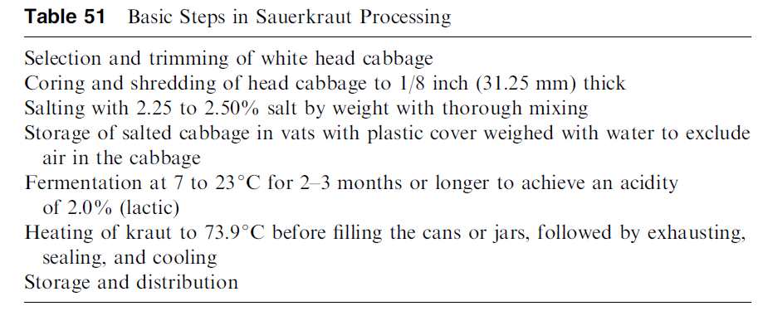

Microorganisms in Sauerkraut fermentation
Sauerkraut fermentation involves many physical, chemical, and microbiological changes that influence the quality and safety of the product. This fermentation can be broadly categorized as having successive stages, including an initial heterofermentative stage followed by a homofermentative stage . Historically, four species of lactic acid bacteria (LAB) have been identified as organisms that are present in sauerkraut fermentations: Leuconostoc mesenteroides, Lactobacillus brevis, Pediococcus pentosaceus, and Lactobacillus plantarum. The identification of these microorganisms has been based on morphological and biochemical criteria.
References
- Y. H. Hui, Handbook of Food and Beverages Fermentation Technology, Marcell Dekker Inc.
- Plengvidhya Vethachai, Breidt Fredrick, Jr., Lu Zhongjing and Fleming Henry P.(2007), DNA Fingerprinting of Lactic Acid Bacteria in Sauerkraut Fermentations, Applied and Environmental Microbiology 73(23): 7697-7702

