Plasmids
Plasmids are circular or linear extrachromosomal replicons that are found in many microorganisms in the domains Bacteria, Archaea, and Eukaryota. Plasmids are circular deoxyribonucleic acid (DNA) molecules that replicate independently of the bacterial chromosome. They are not essential for the bacterium but may confer a selective advantage.
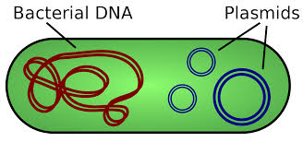
The circular structure of plasmids is made possible by the two ends of the double strands being joined by covalent bonds. The molecules are also small in size, especially when compared to the organisms' DNA, and measure between a few kilobases and several hundred kilobases and may be present in varying numbers in the host cell.
Although a good number of plasmids have a covalently closed circular structure, some plasmids have a linear structure and do not form a circular shape.
Application of plasmids
- Plasmids are used in genetic engineering to amplify, or produce many copies of, certain genes.
- In molecular cloning, a plasmid is a type of vector. A vector is a DNA sequence that can transport foreign genetic material from one cell to another cell, where the genes can be further expressed and replicated. Plasmids are useful in cloning short segments of DNA.
- Plasmids can be used to replicate genes, such as the gene that codes for insulin, in large amounts.
- Plasmids are being investigated as a way to transfer genes into human cells as part of gene therapy. Cells may lack a specific protein if the patient has a hereditary disorder involving a gene mutation. Inserting a plasmid into DNA would allow cells to express a protein that they are lacking.
Types of plasmids
Although plasmids share various general characteristics, there are different types in existence.
F plasmid
The F plasmid is a conjugative plasmid also called the fertility factor or sex factor (F), it contains genes that allow the plasmids DNA to be transferred between cells. It is found in the bacterium E. coli; E. coli containing this F factor are known as F⁺ and those without are known as F⁻.
The F factor is 100 kb of duplex DNA with two replication-origin regions. The oriV or vegetative replication region contains two replication origins, one of which is used for bidirectional maintenance replication of the plasmid when it is not being transferred to another cell. oriT, the transfer origin, promotes a special mode of unidirectional, single-(leading) strand replication used during conjugative transfer of the F factor to another cell.
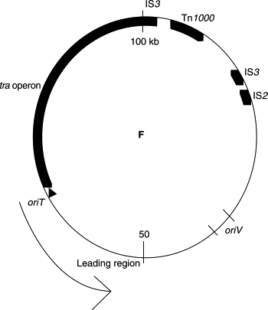
Figure: The F factor is a 100-kb conjugative plasmid. The tra operon encodes functions required for conjugative transfer of the F factor. Transposable elements are indicated: IS3, IS2, and Tn1000, and the direction of transfer is indicated by the thin arrow.
Properties of F plasmid
- The F plasmid can replicate its own DNA, allowing the plasmid to be maintained in a dividing cell population.
- Cells carrying the F plasmid promote the synthesis of pili (singular, pilus) on the bacterial cell surface. Pili are minute proteinaceous tubules that allow the F⁺ cells to attach to other cells and maintain contact with them; that is, to conjugate.
- F⁺ and F⁻ cells can conjugate. When conjugation occurs, the F⁺ cells can act as F donors. The F plasmid DNA replicates and the newly synthesized copy of the circular F molecule is transferred to the F⁻ recipient. However, a copy of F always remains behind in the donor cell. The recipient cell becomes converted into F⁺, because it now contains a circular F genome. The transfer of the F plasmid from F⁺ to F⁻ is rapid, so the F plasmid can spread like wildfire throughout a population from strain to strain.
- F⁺ cells are usually inhibited from making contact with other F⁺ cells; therefore the F plasmid is not transferred from F⁺ to F⁺.
- Sometimes F carries within its genome one or more IS (insertion-sequence) element. An IS element is a mobile segment of DNA that moves from place to place within the host chromosome or between chromosome and plasmid. The existence of a specific IS element both in the plasmid and in the chromosome affords a site at which homologous crossing-over occasionally occurs. A crossover between the two circular DNAs leads to the integration of the plasmid into the bacterial chromosome. When this integration occurs, F can drive the transfer of the entire host chromosome into the recipient cell, along with its own integrated F DNA. Strains with an integrated F factor are termed high frequency of recombination (Hfr) strains to distinguish them from normal F⁺ strains because in such strains, every cell donates chromosomal alleles during F transfer, so the frequency of recombinants for these strains is much higher than it is for cells in the original population, where the F factor is not integrated in most cells.
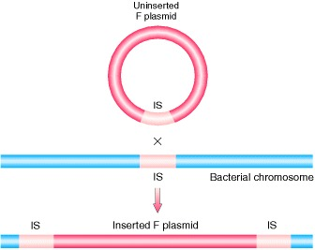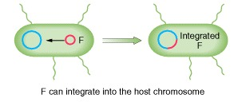

- The integrated F factor occasionally leaves the chromosome of an Hfr cell and moves back to the cytoplasm, in some rare cases carrying a few host chromosomal genes along with it. This modified F, called F′ (pronounced “F prime”), can now transfer these specific host genes to a recipient (F⁻) cell in an infectious manner, in the same way that F is spread. Thus, the recipient cell now contains two copies of the same gene—one resident copy on its bacterial chromosome and one copy on the newly transferred cytoplasmic F′ factor.
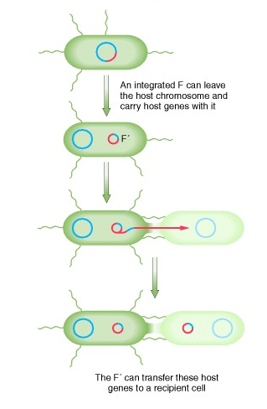
- F factor is a low-copy-number (1-2 copies per cell) plasmid whose replication is stringently controlled.
- The F factor is considered as an episome, i.e., a replicon that can exist either outside, or integrated into, the bacterial chromosome.
References
https://www.ncbi.nlm.nih.gov/books/NBK21351/
https://www.sciencedirect.com/science/article/pii/B0122270800004547
https://www.asmscience.org/files/Chapter_126_Structure_and_Function_of_the_F_Factor_and_Mechanism.pdf

