Pickles
Pickles are usually made from a mixture of vegetables and fruit. They are eaten as a savoury, spicy accompaniment to a meal. Pickles are preserved by a combination of increased acidity (reduced pH), added salt, reduced moisture and added spices. Pickles can be prepared using one of two main methods: lactic acid fermentation of vegetables, either with or without the addition of salt the preservation of vegetables in acetic acid (vinegar). The products made by these two methods are very different -each one has its own distinctive taste and texture. Vegetables such as cucumber, cabbage, olive and onion are fermented by lactic acid bacteria which can grow in low concentrations of salt.
Production Process
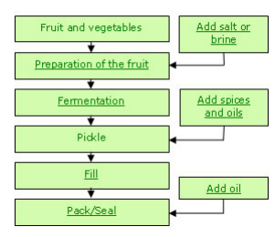
Fig – Production process of Pickles
Prepared vegetables are placed in the fermentation container and salt or brine is added. The vegetable pieces are weighted down so that they are submerged in the brine. The vegetables and salt are placed in alternate layers until the container is three quarters full. As a guide, 3kg salt are required for every 100kg vegetables. A container with a lid should be used for fermentation. This is to maintain the temperature at the optimum level and to prevent contamination from dust and insects. If brine is being used, a 15-20% brine solution is prepared by dissolving salt in water. This is measured using a salometer or brine hydrometer. A starter culture of juice from a previous fermentation may be added to speed up the fermentation. The temperature and time of fermentation must be carefully controlled. The optimum temperature is 21°C. Fermentation begins as soon as a brine is formed. It can be seen by bubbles of carbon dioxide gas that are given off by the bacteria. Fermentation takes between one and four weeks depending upon the temperature, pH and strength of the salt solution. It is completed when no more bubbles appear
Microorganisms
Starter cultures are used to speed up the fermentation and to ensure consistency between different batches of pickle. Because they are acidic, the starter cultures inhibit the growth of undesirable organisms. It is possible to use fermented pickle juice that has been saved from a previous fermentation as the starter culture. It is important to ensure that the acidity of the starter juice is not too acidic as this will inhibit the activity of the Leuconostoc bacteria. Starter cultures of Lactobacillus species can be purchased from ingredient suppliers, but they may not be readily available in all countries
Reference
http://www.fao.org/3/a-au116e.pdf

