Amino acid reaction with Ninhydrin
Ninhydrin (2,2-dihydroxyindane-1,3-dione) is a chemical used to detect ammonia or primary and secondary amines. When reacting with these free amines, a deep blue or purple color known as Ruhemann's purple is produced.
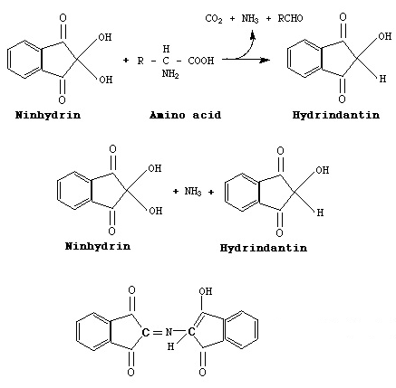

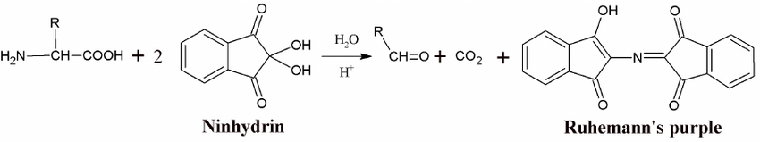
Ninhydrin is the hydrate of indane-1,2,3-trione. With the exception of proline and hydroxy-proline, all the alpha-amino acids found in proteins react with ninhydrin to give the same intensely colored purple anion (570 nm). The purple anion consists of two ninhydrin molecules, each minus their hydroxy groups and bonded together by a central nitrogen. The nitrogen is the only portion of the purple anion that is derived from the amino acid.

