Mesosomes
Mesosomes are the invaginated structures formed by the localized infoldings of the plasma membrane. The invaginated structures comprise of vesicles, tubules of lamellar whorls.
Mesosomes are part of the structure of the plasma membrane. You'll find them lining the cell wall. They are clumped and folded together, to maximize their surface area. This is important because it is needed for cell respiration, which is a function of the mesosomes. These folds can become distinct vesicles, which can then be used to contain material, keeping it distinct from the remainder of the cell. mesosomes are the infoldings in the plasma membrane, these are rich in enzymes that helps to perform functions like cellular respiration, DNA replication, secretion of glycocalyx and cell division(most important function; it increases the surface area of the cell membrane
Functions of mesosome in prokaryotic cells are:
1) involved in septum formation during cell division.
2) control the activity of autolytic enzymes (enzymes that aid in breakdown of cells or tissue).
3) site where photosynthetic apparatus in photosynthetic bacteria rest (photosynthesis or respiration).
4) carry a site for the attachment of signal peptides.
5) have a specific attachment site for DNA during replication and contain enzymes required during that process.
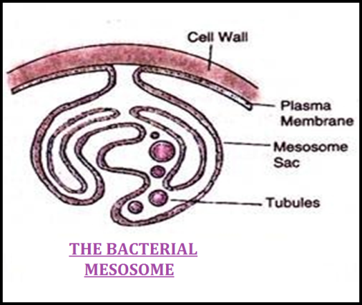
In the vesicle of mesosomes the respiratory enzymes and the components of electron transport such as ATPase, dehydrogenase, cytochrome are either absent or present in low amount. This emphasizes their inability to carryout transport process in which the membrane is energized. In addition, mesosomes are supposed as a site for synthesis of some of wall membranes.
Mesosomes might play a role in reproduction also. During binary fission a cross wall is formed resulting in formation of two cells. Mesosomes begin the formation of septum and attach bacterial DNA to the cell membrane. It separates the bacterial DNA into each daughter cell. In addition, the infoldings of mesosomes increase the surface area of plasma membrane that in turn increases the absorption of nutrients.

