Ion-exchange chromatography
Ion Exchange chromatography relies on the attraction between oppositely charged stationary phase, known as an ion exchanger, and analyte. It is frequently chosen for the separation and purification of proteins, peptides, nucleic acids, polynucleotides and other charged molecules, mainly because of its high resolving power and high capacity.

There are two types of ion exchanger, namely cation and anion exchangers.
Cation exchangers possess negatively charged groups and these will attract positively charged cations. These exchangers are also called acidic ion exchangers because their negative charges result from the ionisation of acidic groups.

Anion exchangers have positively charged groups that will attract negatively charged anions. The term basic ion exchangers is also used to describe these exchangers, as positive charges generally result from the association of protons with basic groups.
Choice of exchanger
The choice of the ion exchanger depends upon the stability of the test analytes, their relative molecular mass and the specific requirements of the separation.
Many biological analytes, especially proteins, are stable within only a fairly narrow pH range so the exchanger selected must operate within this range. Generally, if an analyte is most stable below its isoionic point (giving it a net positive charge) a cation exchanger should be used, whereas if it is most stable above its isoionic point (giving it a net negative charge) an anion exchanger should be used.
Either type of exchanger may be used to separate analytes that are stable over a wide range of pH values. The choice between a strong and weak exchanger also depends on analyte stability and the effect of pH on analyte charge.
Weak electrolytes requiring a very low or high pH for ionisation can be separated only on strong exchangers, as they only operate over a wide pH range. In contrast, for strong electrolytes, weak exchangers are advantageous for a number of reasons, including a reduced tendency to cause protein denaturation, their inability to bind weakly charged impurities and their enhanced elution characteristics.
Although the degree of cross-linking of an exchanger does not influence the ion-exchange mechanism, it does influence its capacity. The relative molecular mass and hence size of the proteins in the sample therefore determines which exchanger should be used.

Eluent pH
The pH of the buffer selected as eluent should be at least one pH unit above or below the isoionic point of the analytes.
In general, cationic buffers such as Tris, pyridine and alkylamines are used in conjunction with anion exchangers, and anionic buffers such as acetate, barbiturate and phosphate are used with cation exchangers.
The precise initial buffer pH and ionic strength should be such as just to allow the binding of the analytes to the exchanger. Equally, a buffer of the lowest ionic strength that effects elution should initially be used for the subsequent elution of the analytes. This ensures that initially the minimum numbers of contaminants bind to the exchanger and that subsequently the maximum number of these impurities remains on the column.

As shown in Fig, Ion-exchange chromatography exploits differences in the sign and magnitude of the net electric charges of proteins at a given pH. The column matrix is a synthetic polymer containing bound charged groups; those with bound anionic groups are called cation exchangers, and those with bound cationic groups are called anion exchangers. Ion-exchange chromatography on a cation exchanger is shown here. The affinity of each protein for the charged groups on the column is affected by the pH (which determines the ionization state of the molecule) and the concentration of competing free salt ions in the surrounding solution. Separation can be optimized by gradually changing the pH and/or salt concentration of the mobile phase so as to create a pH or salt gradient.
Affinity chromatography
Introduction -
Affinity chromatography is a versatile separation protocol that uses the biological interactions for characterization and detailed analysis of sample components. It is based on highly specific interactions between two molecules, such as the interactions between enzyme and its substrate, receptor, and ligand, or antibody and antigen. These reversible interactions are used for the purification by placing one of the interacting molecules, considered as affinity ligand, onto a matrix to make a stationary phase while the target molecule is run through the mobile phase. Highly selective nature of the method enables a fast, single-step purification of the sample components from several hundred to thousand-fold. Other applications of the technique include the study of drug or hormone interactions with the binding proteins, the ability to concentrate substances present at low concentration and to separate the proteins based on their biological function. The development of the affinity liquid chromatography has enabled the biomedical researchers to explore and investigate protein-protein interactions, post-translational modifications, and protein degradation.
Principle
The stationary phase of the affinity chromatography consists of a support medium (e.g., cellulose beads or agarose with beads) on which the substrate is attached covalently to expose the reactive groups essential for enzyme binding. As the crude protein mixture is passed through the chromatography column, proteins with a binding site for the immobilized substrate bind to the stationary phase, while all the other components of the sample are eluted in the void volume of the column.
Affinity chromatography is based on binding affinity. The beads in the column have a covalently attached chemical group called a ligand-a group or molecule that binds to a macromolecule such as protein.
When a protein mixture is added to the column, any protein with affinity for this ligand binds to the beads, and its migration through matrix is retarded.
For example, if the biological function of a protein involves binding to ATP, then attaching ATP to the beads in the column creates an affinity matrix that can help purify protein. As the protein solution moves through the column, ATP- binding proteins (including protein of interest) bind to the matrix. After proteins that do not bind the matrix are washed through the column, the bound protein is eluted by a solution containing either a high concentration of salt or free ligand- in this case , ATP.
Salt weakens the binding of the protein to the immbolized ligand, intereferring with ionic interactions.
Free ligands competes with the ligand attached to the beads, releasing the protein from the matrix,the protein product that elutes from the column is often bound to the ligand used to elute it.
As shown in fig . Affinity chromatography separates proteins by their binding specificities. The proteins retained on the column are those that bind specifically to a ligand cross-linked to the beads. (In biochemistry, the term “ligand” is used to refer to a group or molecule that binds to a macromolecule such as a protein.) After proteins that do not bind to the ligand are washed through the column, the bound protein of particular interest is eluted (washed out of the column) by a solution containing free ligand.

A modern refinement in chromatographic methods is HPLC, or high-performance liquid chromatography. HPLC makes use of high-pressure pumps that speed the movement of the protein molecules down the column, as well as higher-quality chromatographic materials that can withstand the crushing force of the pressurized flow.
HPLC is an abbreviation for High Performance Liquid Chromatography. "Chromatography" is a technique for separation, "chromatogram" is the result of chromatography, and "chromatograph" is the instrument used to conduct chromatography.
Among the various technologies developed for chromatography, devices dedicated for molecular separation called columns and high-performance pumps for delivering solvent at a stable flow rate are some of the key components of chromatographs. As related technologies became more sophisticated, the system commonly referred to as High Performance Liquid Chromatography, simply became referred to as "LC". Nowadays, Ultra High Performance Liquid Chromatography (UHPLC), capable of high-speed analysis, has also become more wide-spread.
Only compounds dissolved in solvents can be analyzed with HPLC. HPLC separates compounds dissolved in a liquid sample and allows qualitative and quantitative analysis of what components and how much of each component are contained in the sample.
Fig.1 shows a basic overview of the HPLC process. The solvent used to separate components in a liquid sample for HPLC analysis is called the mobile phase. The mobile phase is delivered to a separation column, otherwise known as the stationary phase, and then to the detector at a stable flow rate controlled by the solvent delivery pump. A certain amount of sample is injected into the column and the compounds contained in the sample are separated. The compounds separated in the column are detected by a detector downstream of the column and each compound is identified and quantified.

The Apparatus of the HPLC
The “Basic Overview of the HPLC process"(As shown in Fig.1) and its mechanisms have now been covered. Going into more detail, HPLC consists of a variety of components, including a solvent delivery pump, a degassing unit, a sample injector, a column oven, a detector, and a data processor. Fig.2 shows the HPLC flow diagram and the role of each component.

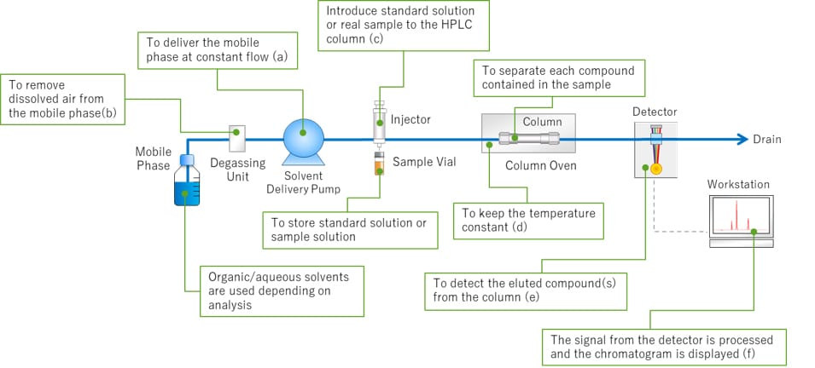
Fig.2 HPLC Flow Diagram
As for HPLC, the pump delivers the mobile phase at a controlled flow rate(a). Air can easily dissolve in the mobile phase under the standard atmospheric pressure in which we live in. If the mobile phase contains air bubbles and enters the delivery pump, troubles such as flow rate fluctuations and baseline noise/drift may occur. The degassing unit helps prevent this issue by removing air bubbles in the mobile phase(b). After the dissolved air has been removed, the mobile phase is delivered to the column. The sample injector then introduces a standard solution or sample solution into the mobile phase (c). Temperature fluctuations can affect the separation of compounds in the column. The column is placed in a column oven to keep the temperature constant(d). Compounds eluted from the column are detected by a detector which is placed downstream of the column(e). A workstation processes the signal from the detector to obtain a chromatogram to identify and quantify the compounds(f).

3 HPLC Separation
HPLC can separate and detect each compound by the difference of each compound's speed through the column. Fig.3 shows an example of HPLC separation.
There are two phases for HPLC: the mobile phase and the stationary phase. The mobile phase is the liquid that dissolves the target compound. The stationary phase is the part of a column that interacts with the target compound.
In the column, the stronger the affinity (e.g.; van der waals force) between the component and the mobile phase, the faster the component moves through the column along with the mobile phase. On the other hand, the stronger the affinity with the stationary phase, the slower it moves through the column. Fig. 3 shows an example in which the yellow component has a strong affinity with the mobile phase and moves quickly through the column, while the pink component has a strong affinity with the stationary phase and moves through slowly. The elution speed in the column depends on the affinity between the compound and the stationary phase.
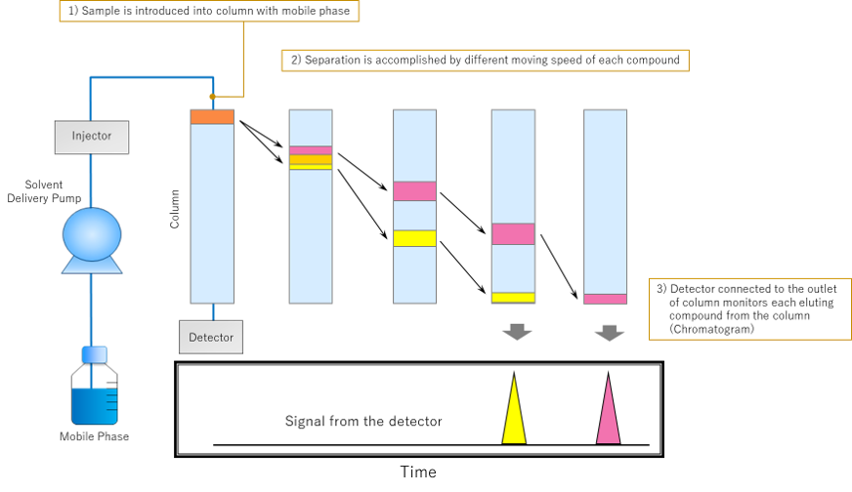

Fig.3 An Example of HPLC Separation

4 How to Read a Chromatogram
The word "chromatogram" means a plot obtained via chromatography. Fig.4 shows an example of a chromatogram. The chromatogram is a two-dimensional plot with the vertical axis showing concentration in terms of the detector signal intensity and the horizontal axis representing the analysis time. When no compounds are eluted from the column, a line parallel to the horizontal axis is plotted. This is called the baseline. The detector responds based on the concentration of the target compound in the elution band. The obtained plot is more like the shape of a bell rather than a triangle. This shape is called a “peak”.
Retention time (tR) is the time interval between sample injection point and the apex of the peak. The required time for non-retained compounds (compounds with no interaction for the stationary phase) to go from the injector to the detector is called the dead time (t0).
The peak height (h) is the vertical distance between a peak's apex and the baseline, and the peak area (A) colored in light blue is the area enclosed by the peak and baseline. These results will be used for the qualitative and quantitative analysis of a sample's components.
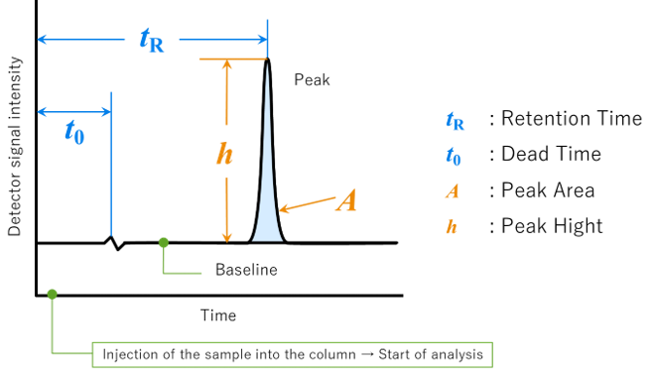
Fig.4 Chromatogram and Related Terms

