Paper CC1: Introduction to Microbiology and Microbial Diversity
Unit 2: Diversity of Microbial World.
B. General Characteristic of different groups

Fungi
The fungi (singular, fungus) are a group of eucaryotic organisms that are of great practical and scientific interest to microbiologists. The science or study of fungi is called Mycology. We have seen the velvety blue and green growth on rotting oranges and lemons as well as on stale cheeses, the whitish-gray furry outgrowths on bread and jam, and the mushrooms in the fields. These are the bodies of fungi. Thus fungi have a diversity of morphological appearances, depending on the species. Fungi comprise the molds and yeasts. Whereas molds are filamentous and multicellular, yeasts are usually unicellular.
Fungi are eukaryotic spore-bearing, that lack chlorophyll. They generally reproduce both sexually and asexually. Alexopoulos and Mims (1979) defined fungi as eukaryotic, spore bearing, achlorophyllous organisms that may reproduce asexually and sexually, and whose filamentous, branched and somatic structures are typically surrounded by cell walls containing chitin, cellulose or both of these substances with many other complex carbohydrates. On the basis of the above mentioned, the characteristics of fungi are-
Habitat- Ubiquitous i.e found everywhere as saprophytes, parasites or hyperparasite or symbionts
Thallus – Thallus (plural, thalli), or body of fungus may consist of single cell as in the yeasts, more typically the thallus consists of filaments, 5 to 10 µm across, which are commonly branched.
Cell wall- cell wall well defined, made up of chitin
Nuclear status- Eucaryotic, Uni-bi-or multi nucleate, homo or heterokaryotic
Nutrition- Heterotrophic
Reproduction- Asexual, sexual or parasexual through spores.
Fungi are ubiquitous organisms found on earth, in water, in moist soil, in compost, or in decomposing organic matter as saprophytes. The fungi grow in diverse habitat. In fact, they are found in almost every available habitat on earth where organic material (living or dead) is present. They are thus universal in distribution. Many of them are terrestrial. They occur in soil which abounds in dead, decaying organic materials. Fungi lack chlorophyll and like animals are unable to manufacture their own food. Fungi obtain readymade food from an external source. All fungi are, therefore, Heterotrophs. In their mode of nutrition, they are Heterotrophic. Thus according to their mode of nutrition, the fungi are classified into two categories, the saprophytes and the fungi are classified into two categories, the saprophytes and the parasites.
Saprophytes grow where dead organic matter abounds in the substratum. Their mode of life is called Saprophytic. Parasites live in or on the living bodies of the organisms (plants and animals) and obtain food on them. This mode of life is called Parasitic. The presence of parasite may cause an abnormal condition of the hosts which is called disease. They are also present in plants and animals as parasites or symbionts and play an essential part in the economy of nature. Fungi are important as parasites, but their impact on the rest of the biosphere is the most striking when they are playing their saprophytic role. Fungi have been decaying plants and animals bodies for the last two billion years and liberating various elements such as nitrogen, phosphorous, potassium, sulphur, iron, calcium, magnesium and zinc. Their complex and multiple enzyme systems enable to function as scavengers in the destruction of celluloses, hemicelluloses, lignins, pectins and various carbohydrates and nitrogenous substances.
- Fungi are heterotrophic in their nutrition. They lack chlorophyll and, therefore, cannot manufacture their own food from carbon-dioxide and water.
- Fungi digest food externally. The basic processes of digestion are the same in molds as in men. Fungi secreate a large number of digestive enzymes, these enzymes are highly specific and are able to control hydrolysis of particular molecules only. Complete digestion of large polymers such as cellulose, hemicellulose and pectin is a stepwise process involving different enzymes, until a simple, soluble molecules is taken up by the fungus. This enables them to digest a wide variety of materials.
- Obligate saprobes- fungi that live on dead organic matter, and are incapable of infecting living organisms. Those capable of causing diseases and of living on dead organic matter are called facultative parasite (or facultative saprobes).
- Facultative parasites- normally grow as saprophytes but have the ability to parasitize also.
Ex- Pythium and Rhizocotina species.
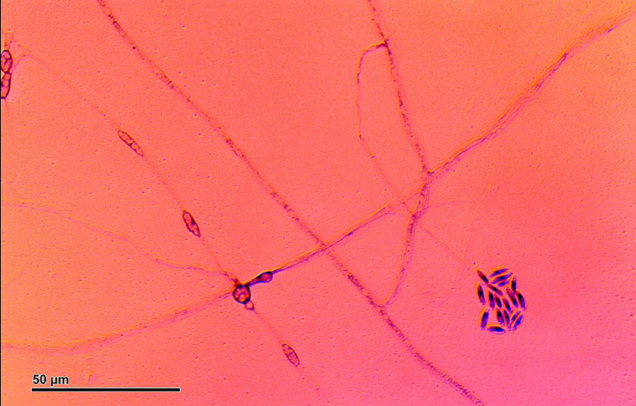 Fig. Pythium species
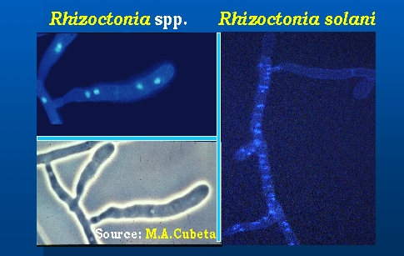 Fig. Rhizoctonia
- Facultative saprophyte- normally grow as parasite but have the ability to live as saprophyte. Ex - smuts
- Organic and inorganic nitrogen and various elements required for fungi growth. Through experimental cultures- growth of fungi is dependent upon carbon (c), Hydrogen (H), Oxygen (O), Nitrogen (N), Potassium (K), Phosphorous (P), Magnesium (Mg), Sulphur (S), Boron (B), Mangenese (Mn), Copper (Cu), Molybdenum (Mo), Iron (Fe), and Zinc (Zn). Biotin and thiamine are also used by fungi for their growth.

