Filtration
Filtration is one of the most common processes used at all scales of operation to separate suspended particles from a liquid or gas, using a porous medium which retains the particles but allows the liquid or gas to pass through. It is possible to carry out filtration under a variety of conditions, but a number of factors will obviously influence the choice of the most suitable type of equipment to meet the specified requirements at minimum overall cost, including:
1. The properties of the filtrate, particularly its viscosity and density.
2. The nature of the solid particles, particularly their size and shape, the size distribution and packing characteristics.
3. The solids: liquid ratio.
4. The need for recovery of the solid or liquid fraction or both.
5. The scale of operation.
6. The need for batch or continuous operation.
7. The need for aseptic conditions.
8. The need for pressure or vacuum suction to ensure an adequate flow rate of the liquid.

A simple filtration apparatus is illustrated in Fig. 10.7, which consists of a support covered with a porousfilter cloth. A filter cake gradually builds up as filtrate passes through the filter cloth. As the filter cake increases in thickness the resistance to flow will gradually increase. Thus, if the pressure applied to the surface of the slurry is kept constant the rate of flow will gradually diminish. Alternatively, if the flow rate is to be kept constant the pressure will gradually have to be increased. The flow rate may also be reduced by blocking of holes in the filter cloth and closure of voids between particles, if the particles are soft and compressible.

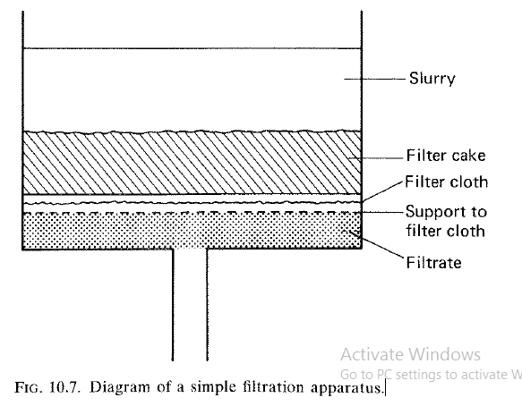
It is common practice to use filter aids when filtering bacteria or other fine or gelatinous suspensions which prove slow to filter or partially block a filter. Kieselguhr (diatomaceous earth) is the most widely used materiaI. It has a voidage of approximately 0.85, and, when it is mixed with the initial cell suspension, improves the porosity of a resulting filter cake leading to a faster flow rate. Alternatively, it may be used as an initial bridging agent in the wider pores of a filter to prevent or reduce blinding. The term 'blinding' means the wedging of particles which are not quite large enough to pass through the pores, so that an appreciable fraction of the filter surface becomes inactive. The minimum quantity of filter aid to be used in filtration of a broth should be established experimentally. Kieselguhr is not cheap, and it will also absorb some of the filtrate, which will be lost when the filter cake is disposed. The main methods of using the filter aid are:
1. A thin layer of kieselguhr is applied to the filter to form a precoat prior to broth filtration.
2, The appropriate quantity of filter aid is mixed with the harvested broth. Filtration is started, to build up a satisfactory filter bed. The initial raffinate is returned to the remaining broth prior to starting the true filtration.
3. When vacuum drum filters are to be used which are fitted with advancing knife blades, a thick precoat filter is initially built up on the drum
In some processes such as microbial biomass production, filter aids cannot be used and cell pretreatment by flocculation or heating must be considered. In addition it is not normally practical to use filter aids when the product is intracellular and its removal would present a further stage of purification.
Types of filter
- Batch Filter – Plate and Frame
- Pressure leaf filter
- Rotary vacuum filter
- Cross- flow filtration

- Batch Filter – plate and frame
A plate and frame filter is a pressure filter in which the simplest form consists of plates and frames arranged alternately. The plates are covered with filter cloths (Fig. 10.8) or filter pads.

The plates and frames are assembled on a horizontal framework and held together by means of a hand screw or hydraulic ram so that there is no leakage between the plates and frames which form a series of liquid-tight compartments.

The slurry is fed to the filter frame through the continuous channel formed by the holes in the corners of the plates and frames. The filtrate passes through the filter
cloth or pad, runs down grooves in the filter plates andis then discharged through outlet taps to a channel.

Sometimes, if aseptic conditions are required, the outlets may lead directly into a pipe. The solids are retained within the frame and filtration is stopped when the frames are completely filled or when the flow of filtrate becomes uneconomically low.

On an industrial scale the plate and frame filter is one of the cheapest filters per unit of filtering space and requires the least floor space, but it is intermittent in operation (a batch process) and there may be considerable wear of filter cloths as a result of frequent dismantling. This type of filter is most suitable for fermentation broths with a low solids content and low resistance to filtration. It is widely used as a 'polishing' device in breweries to filter out residual yeast cells following initial clarification by centrifugation or rotary vacuum filtration. It may also be used for collecting high value solids that would not justify the use of a continuous filter. Because of high labour costs and the time involved in dismantling, cleaning and reassembly, these filters should not be used when removing large quantities of worthless solids from a broth.
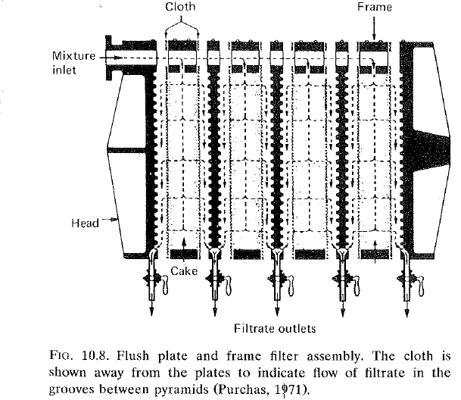

- Pressure leaf filters
There are a number of intermittent batch filters usually called by their trade names. These filters incorporate a number of leaves, each consisting of a metal
framework of grooved plates which is covered with a fine wire mesh, or occasionally a filter cloth and often precoated with a layer of cellulose fibres. The process slurry is fed into the filter which is operated under pressure or by suction with a vacuum pump. Because the filters are totally enclosed it is possible to sterilize them with steam. This type of filter is particularly suitable for 'polishing' large volumes of liquids with low solids content or small batch filtrations of valuable solids.

(i) Vertical metal-leaffilter
This filter consists of a number of vertical porous metal leaves mounted on a hollow shaft in a cylindrical pressure vessel. The solids from the slurry gradually
build up on the surface of the leaves and the filtrate is removed from the plates via the horizontal hollow shaft. In some designs the hollow shaft can be slowly
rotated during filtration. Solids are normally removed at the end of a cycle by blowing air through the shaft and into the filter leaves.

((ii) Horizontal metal-leaffilter
In this filter the metal leaves are mounted on a vertical hollow shaft within a pressure vessel. Often, only the upper surfaces of the leaves are porous. Filtration is continued until the cake fills the space between the disc-shaped leaves or when the operational pressure has become excessive. At the end of a process cycle, the solid cake can be discharged by releasing the pressure and spinning the shaft with a drive motor.

(iii) Stacked-disc filter
One kind of filter of this type is the Metafilter. This is a very robust device and because there is no filter cloth and the bed is easily replaced, labour costs are
low. It consists of a number of precision-made rings which are stacked on a fluted rod (Fig. 10.9). The rings are 22 mm external diameter, 16 mm internal diameter and 0.8 mm thick) are normally made from stainless steel and precision stamped so that there are a number of shoulders on one side. This ensures that there will be clearances of 0.025 mm to 0.25 mm when the rings assembled on the rods. The assembled stacks are placed in a pressure vessel which can be sterilized necessary. The packs are normally coated with a thin layer of kieselguhr which is used as a filter aid. During use, the filtrate passes between the discs and is removed through the grooves of the fluted rods, while solids are deposited on the filter coating. Operation is continued until the resistance becomes too high the solids are removed from the rings by applying pressure via the fluted rods. Metafilters are pnmarilv used for 'polishing' liquids such as beer.

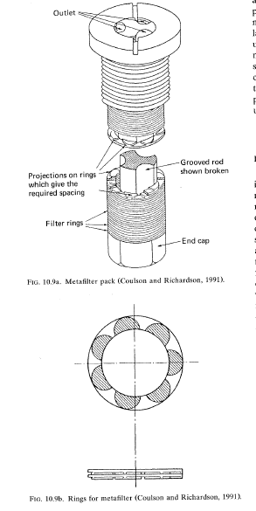

- Rotary vacuum filters
Large rotary vacuum filters are commonly used industries which produce large volumes of liquid need continuous processing. The filter consists rotating, hollow, segmented drum covered with a fabric or metal filter which is partially immersed in a trough containing the broth to be filtered (Fig. 10.10).
slurry is fed on to the outside of the revolving drum and vacuum pressure is applied internally so that the filtrate is drawn through the filter, into the drum and finally to a collecting vessel. The interior of the drum is divided into a series of compartments, to which the vacuum pressure is normally applied for most of each revolution as the drum slowly revolves (~ 1 rpm).
However, just before discharge of the filter cake, air pressure may be applied internally to help ease the filter cake off the drum. A number of spray jets may be carefully positioned so that water can be applied to rinse the cake. This washing is carefully controlled so that dilution of the filtrate is minimal.
It should be noted that the driving force for filtration (pressure differential across the filter) is limited to one atmosphere (l00 kN m-Z) and in practice it is significantly less than this. In contrast, pressure filters can be operated at many atmospheres pressure. A number of rotary vacuum drum filters are manufactured, which differ in the mechanism of cake discharge from the drum:
(i) String discharge.
(ii) Scraper discharge.
(iii) Scraper discharge with precoating of the drum.
(i) String discharge
Fungal mycelia produce a fibrous filter cake which can easily be separated from the drum by string discharge (Fig. 10.11). Long lengths of string 1.5 cm apart are threaded over the drum and round two rollers. The cake is lifted free from the upper part of the drum when the vacuum pressure is released and carried to the small rollers where it falls free.
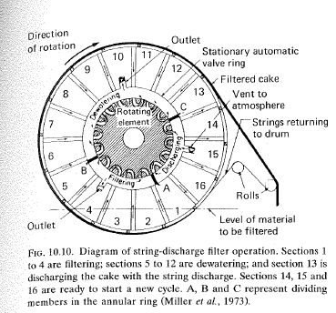

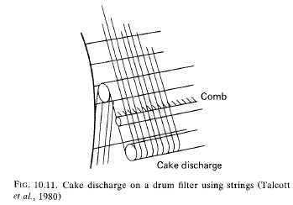
(ii) Scraper discharge
Yeast cells can be collected on a filter drum with a knife blade for scraper discharge (Fig. 10.12). The filter cake which builds up on the drum is removed by an accurately positioned knife blade. Because the knife is close to the drum, there may be gradual wearing of the filter cloth on the drum.
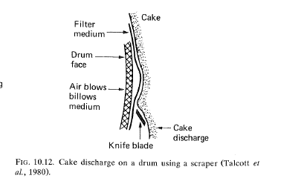
(iii) Scraper discharge with precoating of the drum
The filter cloth on the drum can be blocked by bacterial cells or mycelia of actinomycetes. This problem is overcome by precoating the drum with a layer of filter-aid 2 to 10 em thick.
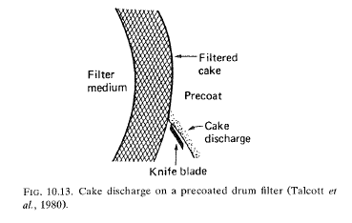
The cake which builds up on the drum during operation is cut away by the knife blade (Fig. 10.13) which mechanically advances towards the drum at a controlled slow rate. Alternatively, the blade may be operated manually when there is an indication of 'blinding' which may be apparent from a reduction in the filtration rate. In either case the cake is removed together with a very thin layer of precoat.

- Cross-flow filtration (tangential filtration)
In the filtration processes previously described, the flow of broth was perpendicular to the filtration membrane. Consequently, blockage of the membrane led to lower rates of productivity and/or the need for filter aids to be added, and these were serious disadvantages.
In contrast, an alternative which is rapidly gaining prominence both in the processing of whole fermentation broths (Tanny et al., 1980; Brown and Kavanagh, 1987; Warren et ai., 1991) and celllysates (Gabler and Ryan, 1985; Le and Atkinson, 1985) is cross-flow filtration. Here, the flow of medium to be filtered is tangential to the membrane (Fig. 10.14(a)), and no filter cake builds up on the membrane.
The benefits of cross-flow filtration are:
(a) Efficient separation, > 99.9% cell retention.
(b) Closed system; for the containment of organisms with no aerosol formation
(c) Separation is independent of cell and media densities, in contrast to centrifugation.
(d) No addition of filter aid
The major components of a cross-flow filtration system are a media storage tank (or the fermenter), a pump and a membrane pack (Fig. 10.14(b)). The membrane is usually in a cassette pack of hollow fibres or flat sheets in a plate and frame type stack or a spiral cartridge. In this way, and by the introduction of a much convoluted surface, large filtration areas can be attained in compact
Two types of membrane may be used; microporous membrane, with a specific pore size (0.45, 0.22 µm etc). or an ultrafiltration membrane with a specified molecular weight cut-off (MWCO). The type of membrane chosen is carefully matched to the product being harvested, with microporous and 100,000 MWCO membranes being used in cell separations.
Many factors influence filtration rate. Increased pressure drop will, up to a point increase flow across the membrane, but it should be remembered that the system is based on a swept clean membrane. Therefore, if the pressure drop is too great the membrane may become blocked. The filtration rate is therefore influenced by the rate of tangential flow across the membrane; by increasing the shear forces at the membrane's surface retained species are more effectively removed, thereby increasing filtration rate. Higher temperatures will increase filtration rate by lowering the viscosity of the media, though this is clearly of limited application in biological systems. Filtration rate is inversely proportional to concentration, and media constituents can influence filtration rate in three ways. Low molecular weight compounds increase media viscosity and high molecular weight compounds decrease shear at the membrane surface, both leading to a reduction in filtration rate. Finally, broth constituents can 'foul' the membrane, primarily by adsorption onto the membrane's surface, causing a rapid loss in efficiency. This can be controlled by modification of the membrane or media formulation in particular by reducing the use of antifoaming agents. Lee et at. (1993) have shown that the pulses of air injected into the flow to a cross-flow filter increase the shear rate at the membrane surface reducing the effects of membrane fouling.
