Epistasis
when two different genes which are not alleles, both affect the same character in such a way that the expression of one masks, inhibits or suppresses the expression of the other gene, it is called epistasis. The suppression of the gene on one locus of a chromosome by the gene present at some other locus is called epistasis meaning "standing over". The gene which is suppressed is called hypostatic and the other is the epistatic or inhibiting gene which is also called the suppressing gene.

Dominant Epistasis
Dominant epistasis happens when the dominant allele of one gene masks the expression of all alleles of another gene. If an organism inherits one or two copies of the dominant allele, they will have the trait. This diagram shows the inheritance pattern for a trait that shows dominant epistasis when both parents are heterozygous for the trait. Heterozygous means that two different alleles for a trait are inherited instead of two of the same allele.
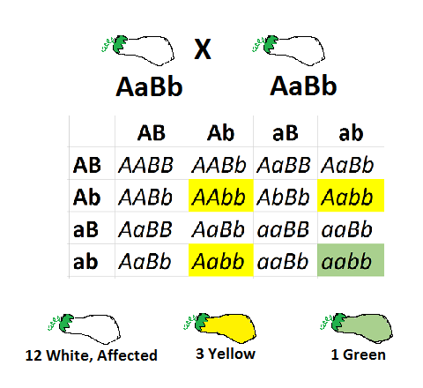
Figure : In dominant epistasis, the majority of the individuals are affected. There is a 12:3:1 ratio.
Fruit and flower color in plants is a common example used to illustrate dominant epistasis. As shown in this figure, the squash comes in 3 colors. Yellow (AA, Aa) is dominant over green (aa). However, since squash color is polygenic, or determined by more than one gene, GeneB also determines squash color. Because GeneB shows epistasis, it is more important than GeneA in determining squash color. This is an example of a bully gene masking the expression of another gene.

Recessive Epistasis:
Epistasis due to recessive genes is called recessive epistasis. In mice albinism (white coat) is produced by a recessive gene aa. There is a different gene B which in the dominant state (BB and Bb) produces grey coat colour called agouti, and when recessive (bb) leads to black coat colour.
The recessive gene for albinism (aa) is found to be epistatic to the gene for agouti (BB and Bb), and also to its recessive, homozygous allele (bb) for black. The presence of the dominant allele (AA) of the epistatic gene allows expression of gene B so that agouti (BB and Bb) and black (bb) coat colours can be produced
