Chair, Boat and Twist-Boat Conformation of Cyclohexanes and Glucose

This tutorial is going to teach you about the different conformations (shapes) of the cyclohexane (C6H12) and the glucose (C6H12O6).

Cyclohexane:
So, a cyclohexane is usually represented like this:
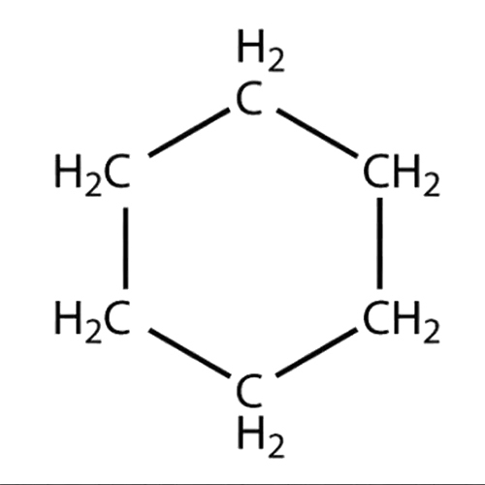
Figure 1: A cyclohexane
Its bond angles between the carbon atoms measure 120°, but is this really accurate? And is there more than one way to represent these tricky molecules?
To start of, what is a cyclohexane?
Well, it is a cyclic hydrocarbon, formed by 6 carbon atoms in a hexagon, with each one bonding to two hydrogen atoms. The molecule is synthesized in millions of kilograms every year, and is used to produce adipic acid and caprolactam. These two are precursors (a compound that participates in a chemical reaction that produces another compound) to nylon, so thanks to the cyclohexane, brush our teeth with nylon brushes, as well as listen to beautiful acoustic guitars.

Creating a cyclohexane:
To start off we need to create the cyclohexane atom. This is done by placing 6 carbon atoms in a rough hexagon, and then adding 2 hydrogen atoms to each carbon atom (that makes 12 hydrogen atoms in total). Now form the bonds between all these atoms and you should end up with something looking like this:
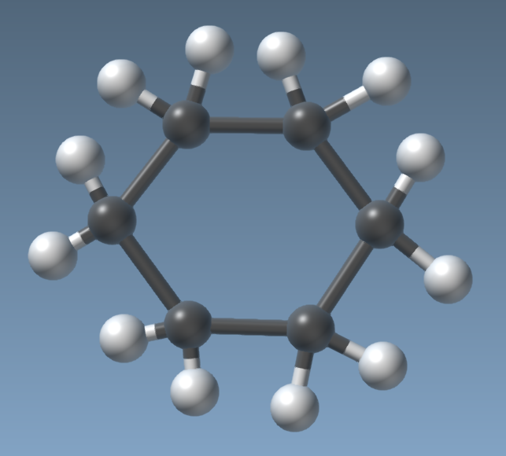
Figure 2: A swiftly created cyclohexane.
You’ve got something looking similar to this? The same amount of atoms atleast? Okay good, let us proceed to the next step, simulation(it is the production of a model of something, especially for the purpose of study).

Well you might know that molecules are always trying to find ways to lower their energy, whether it is by forming bond with other atoms or molecules, or by arranging themselves into new forms and shapes (called conformations). In this case, our cyclohexane is reforming its geometry in favor of one which reduces its potential energy. This specific conformation that we are going to look at in a moment is called the “chair conformation”.

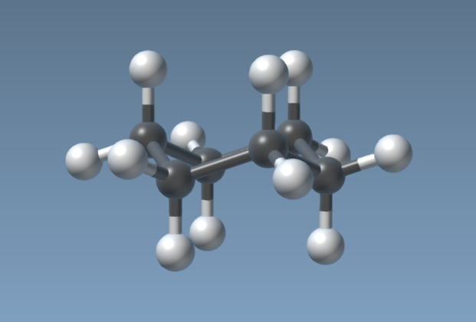Figure 4: The chair conformation. Do pay attention to the positioning of the hydrogen atoms.

The molecule have stabilized and now we can analyze it.
Firstly what is its energy level (given in kJ/mol)?

So, this is the chair conformation, that is represented in the classic way like this:
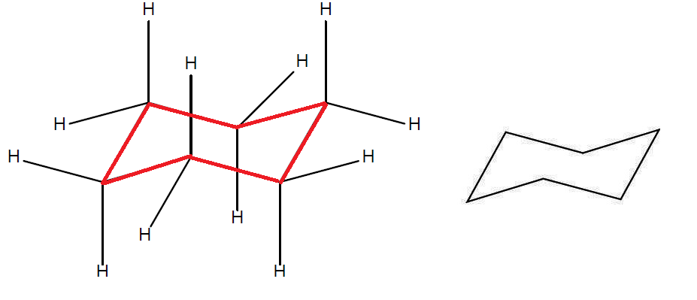
Figure 5: Atoms positioned in the chair conformation.
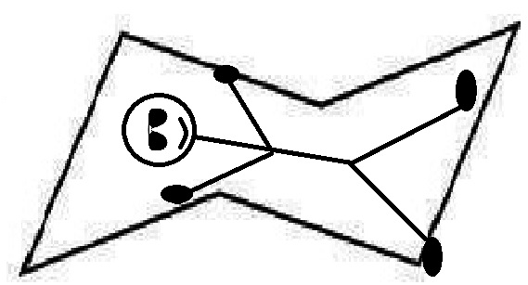
Figure 6: The reason it is called “the chair”
This is the geometry that gives the cyclohexane its lowest potential energy possible. Depending on the position of the hydrogen atoms, we give them different names. The ones pointing right up or down (north or south) are in what we call the axial position. These atoms are perpendicular to the plane of the carbon hexagon. The ones pointing out to the sides are in the equatorial position, and lie in the plane (parallel to it). I hope, this picture below will clear things up.
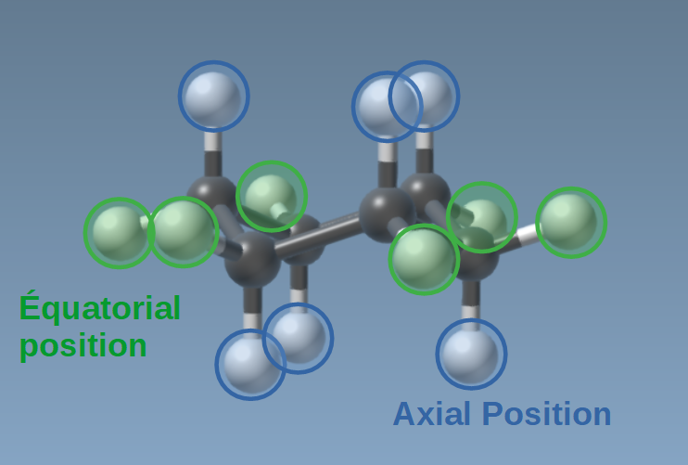
Figure 7: The equatorial and axial positions of the hydrogen atoms
Now we should try to pass to another conformation, namely “the twist-boat”. To do this, we will need to use the mouse cursor button to move (or rather force) one of the outermost carbon atoms to point in the same direction (up or down) as the opposite one. This would look something like this:
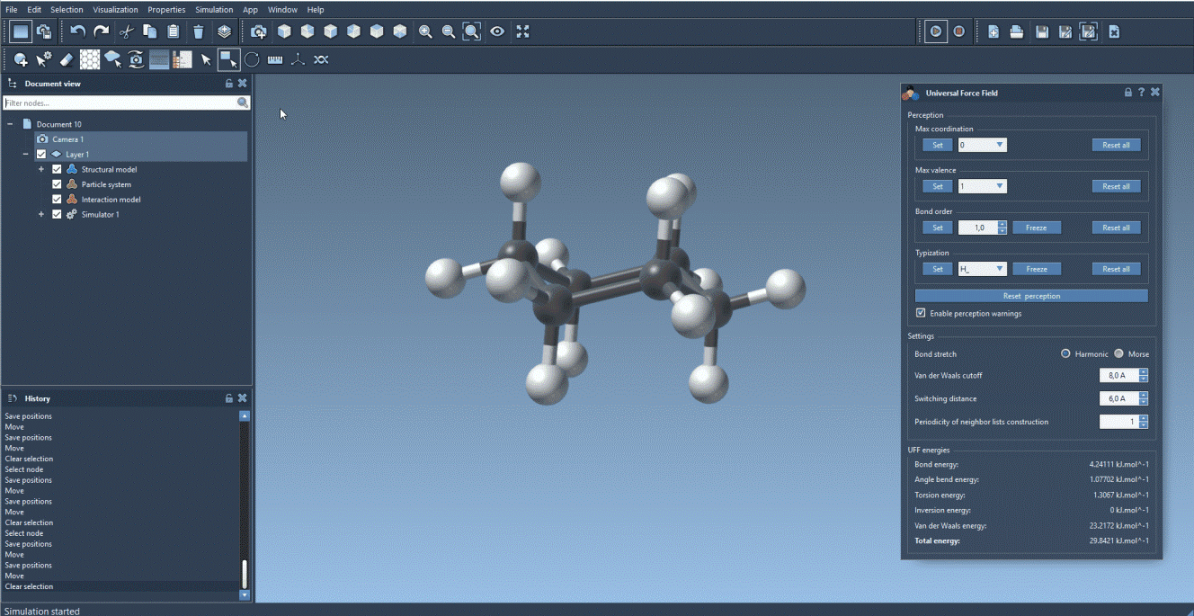
Figure 8: Passing from “the chair” to “the twist-boat”
So this is the twist-boat conformation, and on paper (in a classic manner) it is described like this:
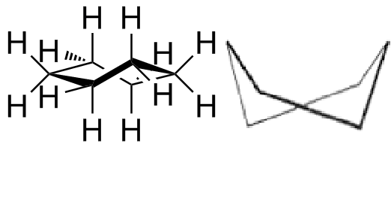
Figure 9: The twist-boat conformation.

Alright, so as you have noticed by now, the chair conformation has a lower energy (and is therefore more stable) than the twist-boat conformation. Well, then how is the twist-boat conformation possibly stable? Usually if a certain geometry is “less stable” than another one, it is not considered stable at all.

Question: With help of the diagram below, explain the existence of multiple stable conformations for a cyclohexane, for example the chair and the twist-boat.

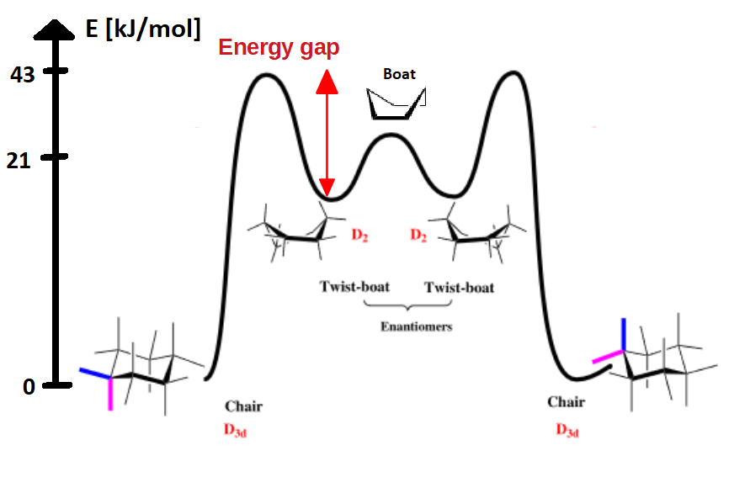
Figure 10: Energy diagram

Explanation:
Well, the C6H12 actually has multiple stable conformations, with the chair being the one with the lowest energy. This is made possible by a slight drop in potential energy just as the molecule passes to the twist-boat conformation. We can see in this energy diagram that if we want to pass from the twist-boat to the chair, we will need to increase the energy about 22 kJ/mol before reaching the peak at 43 kJ/mol where we will start to descend towards the chair conformation at the very bottom (at 0 kJ/mol). Generally, molecules don’t like to increase their energy, so therefore the twist-boat conformations are also stable, and the cyclohexane will stay in these conformations. However, if we were to increase the energy of the molecule by adding external energy to the molecule (perhaps by increasing the temperature), we could pass over the energy.

We see the boat conformation in the middle, which is a conformation that the molecule just pass by (since its energy is higher than the more stable twist-boat’s energy). In mathematical terms we can express this as the boat conformation not being a local minimum point of the energy.

Glucose:
This phenomenon is not unique to the cyclohexane, and can actually be observed for the glucose molecule as well. Let us try to recreate some of the glucose conformations together!
First of all, what is glucose? You have all heard of the photosynthesis, the way our plants make their food, and how important it is for us. The two products of this essential reaction is oxygen (for us humans) and glucose, a simple sugar (monosaccharide) with the molecular formula C₆H₁₂O₆.

Components of glucose: 5 carbon molecules and 1 oxygen in a hexagon, with 4 hydroxyl (OH) groups placed on the carbons, except for the one right next to the oxygen molecule within the hexagon. On this carbon we place CH₂OH group while also adding 5 hydrogens, one to each 5 carbons. With the help of this description and these photos, you should be able to recreate this molecule.
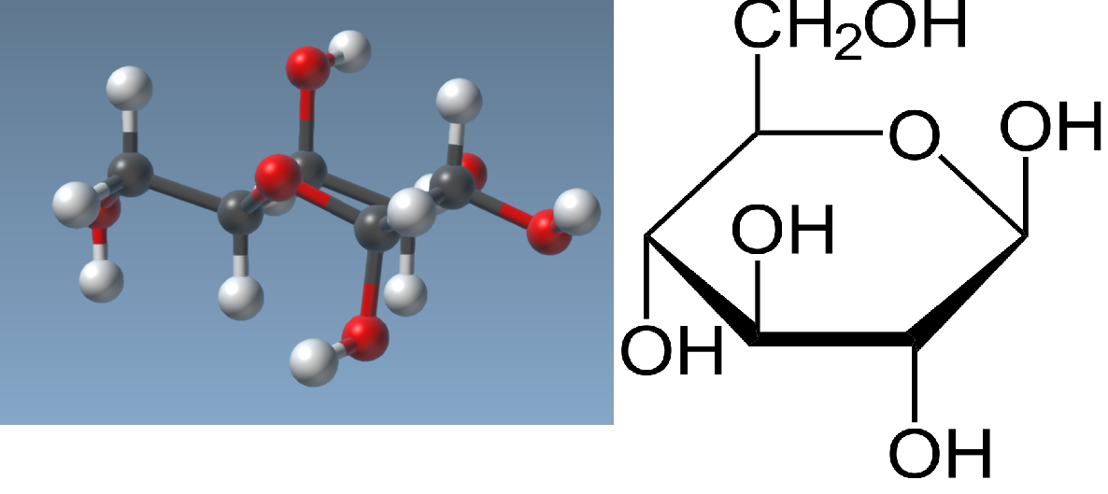
Figure 11: The glucose molecule (left) and in the Haworth projection (right).

This first conformation is called the chair conformation. What is this position and what is the energy level [kJ/mol]?
These different positions (equatorial or axial) give the type of glucose: alpha or beta. In an aqueous solution the glucose turns from beta to alpha through a linear form with different little reactions. This phenomenon is called mutarotation (ΔE). The linear form has an aldehyde group, it is why the Fehling’s solution react with them. The Fehling’s solution is a complex ( Cu(tart)2 ) with a Cu²+ ion which gives the characteristic blue colors. The complex oxidizes the aldehyde group to give a carboxylic acid group, and the Cu²+ ion becomes a copper (I) oxide Cu₂O which gives the characteristic red colors, as shown by the figure12.
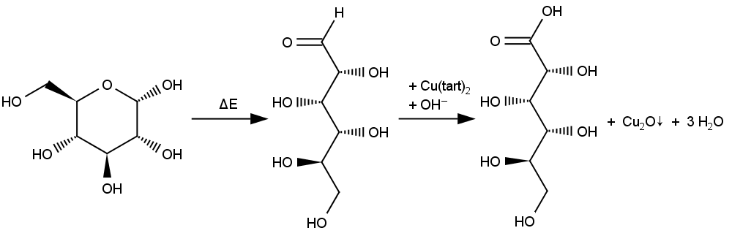
Figure 12: Oxidation of aldehyde group of D-glucose with Fehling’s solution
Conclusion:
So in this tutorial, we have seen how a molecule’s conformations change its internal energy. Its energy levels are changing depending on the conformation, as well as the positions of the atoms, allowing for different interactions with other molecules depending on these positions (for example different polarities for different conformations).
We can also deduce the most common type of conformation, being of course the one with the lowest potential energy. In the case of the cyclohexane, less than 0.1 % of the molecules are in the stable twist-boat conformation at room temperature, but when heated to high temperatures (1073 K) it can reach up to 30 %. If the molecules are subsequently very rapidly cooled, the number of molecules in this conformation are kept and we obtain a high concentration of twist-boat cyclohexanes.

Glucose: ring form

Ring Shapes | Glucose molecules form rings. The first carbon atom (C1), which is an aldehyde group (-CHO), creates a hemiacetal with the fifth carbon atom (C5) to make a 6-membered-ring (termed as pyranose). The atoms in this cyclic molecule then arrange themselves in space to minimize the amount of strain on each of the covalent bonds.  The carbon atoms in the glucose ring each have four covalent bonds. The optimum angle, between all these bonds is 109.5º, which results in a perfect tetrahedron. If, for any reason, these bonds are forced into greater, or smaller angles then the molecule will be strained or stressed, and be much less stable.  It follows, therefore, that the glucose molecule will be at its most stable when all the carbon atoms can arrange themselves so that their bond angles are all close to 109.5º.
Cyclohexane | Some idea of how these considerations affect the shape of the molecule in space can be seen by examining the molecule cyclohexane (C₆H₁₂), which also forms a simple three-dimensional ring in space. The molecule could be drawn out in several different ways, thus:
 | The flat or planar version is the most unlikely since, in this arrangement the carbon bond angles would be at least 120º, which is greater than the optimum. Also, in this form, every carbon atom is lined up with every other carbon atom, that forces the hydrogen atoms to also line up, or eclipse one another. This puts the molecule under a lot of strain.
In the boat conformation some of these strains are lessened, and many of the bond angles are much closer to the optimum degree, however two of the hydrogen atoms at the front and back of the "boat" are forced very close to one another (this is called "steric hindrance"), and this arrangement is still stressful.
Moving one end of the "boat" downwards produces the chair version of the ring. This shape relieves almost all the stresses and strains, and thus would be the most stable. In this arrangement, six of the hydrogen atoms stick out of the side of the molecule, like oars (termed "equatorial") and the other six stick up or down from the molecule like flags (termed "axial"). This is also a very stable arrangement as no hydrogen eclipses any adjacent hydrogen.
Glucose
Following the example of the cyclohexane molecule, the glucose molecule will also be most stable when it is arranged into a chair shape or conformation.

